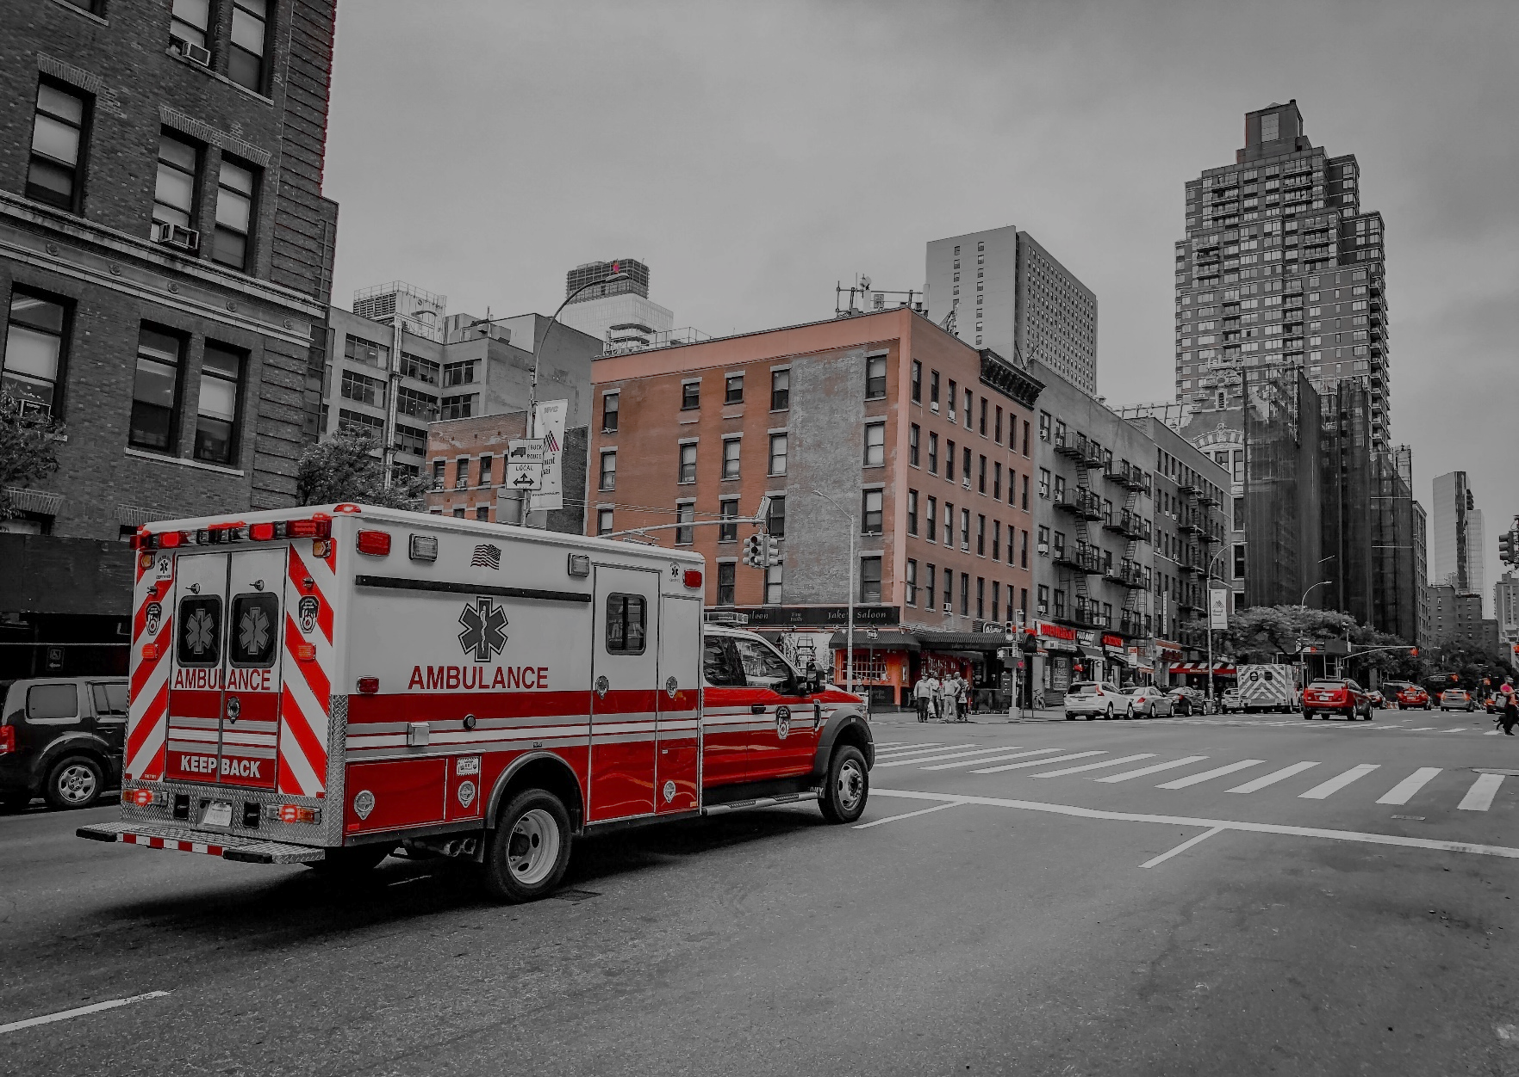

**Ambulance Services Consumer Tip Sheet**

**Tips for Protecting Yourself and Medicare**

Ambulance fraud happens when Medicare is charged for services that are not   
medically necessary or do not meet other strict standards. Medicare Part B only covers medically necessary ambulance services certain strict criteria are met.

**What Does Medicare Cover in Relation to Ambulance Services?**

Medicare covers ground and air ambulance transportation when all of these criteria are met:

* The transportation is medically necessary.
* A wheelchair van or car could endanger the patient.
* It is the only means of transporting the patient safely.
* The ambulance and its crew meet certain standards.
  + At a minimum, ambulance vehicles must be equipped with a stretcher, emergency medical supplies, oxygen equipment, emergency warning lights and sirens, and telecommunications equipment, as required by state or local law.
* The destination is the nearest appropriate facility that can treat the beneficiary’s condition.
  + Covered: Transport to hospitals, skilled nursing facilities (SNFs), dialysis facilities for End-Stage Renal Disease (ESRD) beneficiaries who require dialysis, and return trips to a beneficiary’s home when necessary.
  + Non-covered: Transport from home to doctor appointments, community mental health centers, psychiatric facilities (outside of a hospital), or independent l abs not connected with a hospital or SNF.

**Examples of Fraud Schemes**

* Falsification of documentation to provide the appearance of medical necessity when medical necessity did not exist.
* Billing for more miles than traveled for transport.
* Billing nonemergency trips as emergency trips.
* Billing a ride in a taxi or wheelchair van as an emergency transport.
* Billing the beneficiary instead of Medicare, even though the provider participates in Medicare and the trip met Medicare’s coverage criteria.



**What Can You Do to Stop Ambulance Fraud?**

* Review your Medicare Summary Notice (MSN) and/or Explanation of Benefits (EOB) and look for the following:
  + The services listed match what you actually received.
  + The mileage billed isn’t more than the distance traveled.
  + That you weren’t billed for emergency transport if there wasn’t an emergency.
* Be on the lookout for upcoding on transport claims from basic life support (BLS) to advanced life support (ALS).
  + - ALS vehicles must be staffed by at least two people, who each must be certified as an EMT-Intermediate or an EMT-Paramedic by the state or local authority where the services are being furnished to perform one or more ALS services.
* If you find billing errors or have concerns, contact your Senior Medicare Patrol at [www.smpresource.org](http://www.smpresource.org) or 1-877-808-2468.
* For Medicare coverage questions, contact your local State Health Insurance Assistance Program (SHIP) at www.[SHIPTAcenter.org](https://shiptacenter.org) or 1-877-839-2675.

**Other Ambulance Resources**

* Senior Medicare Patrol National Resource Center (SMPNRC): <https://www.smpresource.org/Content/Medicare-Fraud/Fraud-Schemes/Ambulance-Fraud.aspx>
* Centers for Medicare & Medicaid Services (CMS): <https://www.medicare.gov/coverage/ambulance-services>

**How Your Senior Medicare Patrol (SMP) Can Help**

Your local SMP is ready to provide you with the information you need to **PROTECT** yourself from Medicare fraud, errors, and abuse; **DETECT** potential fraud, errors, and abuse; and **REPORT** your concerns. SMPs and their trained volunteers help educate and empower Medicare beneficiaries in the fight against health care fraud. Your SMP can help you with your questions, concerns, or complaints about potential fraud and abuse issues. It also can provide information and educational presentations.

**To locate your state Senior Medicare Patrol (SMP):  
Visit** [**www.smpresource.org**](http://www.smpresource.org) **or call 1-877-808-2468.**

This project was supported, in part, by grant number 90MPRC0002 from the U.S. Administration for Community Living, Department of Health and Human Services, Washington, D.C. 20201. Grantees undertaking projects under government sponsorship are encouraged to express freely their findings and conclusions. Points of view or opinions do not, therefore, necessarily represent official Administration for Community Living policy.