Harm to Beneficiaries Case 3: Respiratory Therapy Services
12.2.21
Facebook Post: "When a beneficiary elects hospice care, the hospice is responsible for providing all services related to the beneficiary’s terminal illness and related conditions. When a hospice does not comply with Medicare requirements, there can be significant consequences for the beneficiary. Although these cases do not represent the majority of hospice beneficiaries or the majority of hospice providers, any instance of harm must be taken seriously," from HHS Office of Inspector General.
To learn more about hospice fraud, errors, or abuse, visit https://smpresource.news/hospicefraud."
Instagram Post: "When a beneficiary elects hospice care, the hospice is responsible for providing all services related to the beneficiary’s terminal illness and related conditions. When a hospice does not comply with Medicare requirements, there can be significant consequences for the beneficiary. Although these cases do not represent the majority of hospice beneficiaries or the majority of hospice providers, any instance of harm must be taken seriously," from HHS Office of Inspector General.
To learn more about hospice fraud, errors, or abuse, visit https://smpresource.news/hospicefraud."
Note: Space was provided in the bottom right corner for your state logo and contact information. Do not remove the national logo, citations, or grant statement.
The below image is used for both Facebook and Instagram and can be scheduled to Instagram directly from Facebook Business Suite, if you would like.
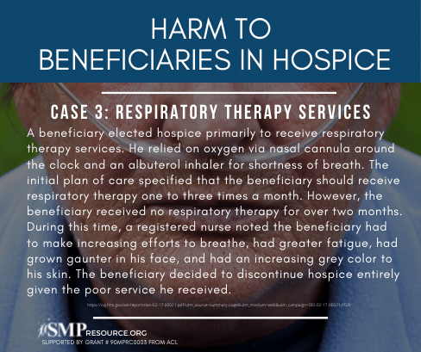
Twitter Post: While #hospice is an important benefit, sometimes there can be harm to beneficiaries. https://smpresource.news/hospicefraud. #SeniorMedicarePatrol
Note: Space was provided in the bottom right corner for your state logo and contact information. Do not remove the national logo, citations, or grant statement.
