What Can You do to Stop Hospice Fraud?
8.16.21
Facebook Post: Hospice is an important benefit for the Medicare population but fraud threatens this benefit for all beneficiaries. Scammers are getting beneficiaries to agree to hospice care even though they do not qualify for the benefit.
Here are some tips to help stop hospice fraud. Contact your local #SeniorMedicarePatrol at 1-877-808-2468 or learn more here: https://smpresource.news/hospicefraud.
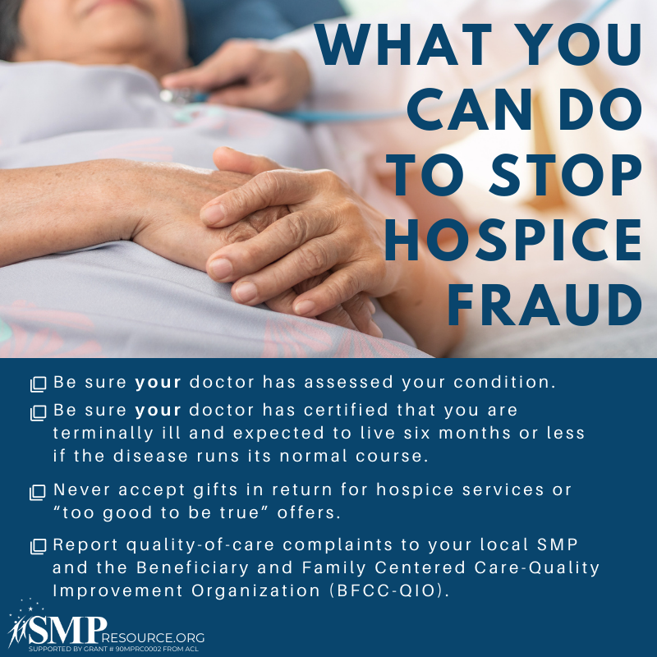
Note: Space was provided in the lower right corner for your state logo and contact information. Do not remove the national logo, citations, or grant statement.

Twitter Post: #Hospice is an important benefit for the Medicare population but #fraud threatens this benefit for all beneficiaries. Here are some tips to help stop hospice fraud. Contact your local #SeniorMedicarePatrol at 1-877-808-2468 or learn more here: https://smpresource.news/hospicefraud.
Note: Space was provided in the lower right corner for your state logo and contact information. Do not remove the national logo, citations, or grant statement.
