4 Free COVID-19 Tests per Household
1.21.22
Facebook and Instagram Post: Did you know you can receive 4 free COVID-19 test kits delivered right to your door? These kits are provided by the government and do not require any kind of payment.
Be on the lookout for scammers using this opportunity to try to collect personal information, like your Medicare or Social Security number. If you have given out your Medicare number over the phone, please report it to the #SeniorMedicarePatrol by calling 877-808-2468 or emailing info@smpresource.org.
Note: Space was provided in the bottom right corner for your state logo and contact information. Do not remove the national logo, citations, or grant statement.
The below image is used for both Facebook and Instagram and can be scheduled to Instagram directly from Facebook Business Suite, if you would like.
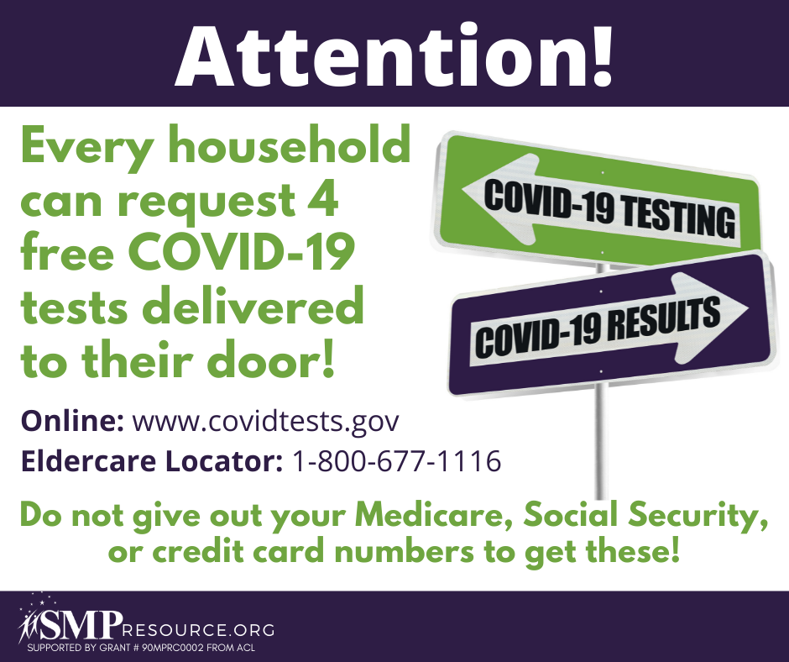
Twitter Post: Be on the lookout for #scammers using this opportunity to try to collect personal information, like your @MedicareGov or @SocialSecurity number. If you have given out your Medicare number over the phone, please report it to the #SeniorMedicarePatrol by calling 877-808-2468.
Note: Space was provided in the bottom right corner for your state logo and contact information. Do not remove the national logo, citations, or grant statement.
