Cardiac Genetic Testing Scam
11.2.21
Facebook and Instagram Post: ‼️Be aware of a new twist on an old scam‼️
While genetic testing scams have been around for a few years, scammers have added cardiac genetic tests to the mix.
Please do not accept these unsolicited offers. If you receive calls about this or have received these kits, please report it to the #SeniorMedicarePatrol at 877-808-2468 or to info@smpresource.org.
Note: Space was provided in the bottom right corner for your state logo and contact information. Do not remove the national logo, citations, or grant statement.
The below image is used for both Facebook and Instagram and can be scheduled to Instagram directly from Facebook Business Suite, if you would like.
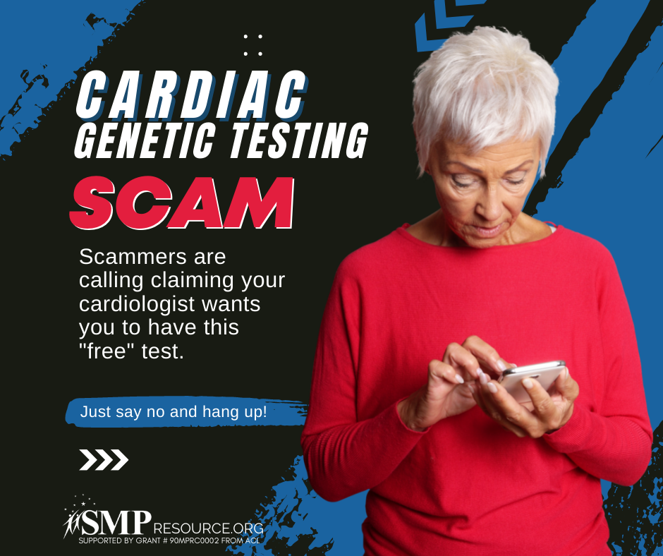

Twitter Post: While #genetictestingscams have been around for a few years, scammers have added #cardiacgenetictests to the mix.
If you receive calls about this or have received these kits, please report it to the #SeniorMedicarePatrol at 877-808-2468 or to info@smpresource.org.
Note: Space was provided in the bottom right corner for your state logo and contact information. Do not remove the national logo, citations, or grant statement.
