Durable Medical Equipment Fraud Sheet

Tips for Protecting Yourself and Your Medicare

Medicare Part B covers medically necessary durable medical equipment, or “DME,” that is prescribed by your doctor, can withstand repeated use, serves a medical purpose, and can be used in the home. Medicare only covers DME if you get it from a supplier enrolled in the Medicare program. Medicare Part B pays 80% of the approved amount and you pay the other 20%.
What Does Medicare Cover in Relation to DME, Orthotics, and Prosthetics?
- DME that Medicare covers includes, but is not limited, to:
  - Blood sugar monitors and test strips, canes, continuous positive airway pressure (CPAP) devices, crutches, hospital beds, infusion pumps and supplies, oxygen equipment and accessories, patient lifts, walkers, wheelchairs, and scooters
- Prefabricated orthotics that Medicare covers include, but are not limited, to:
  - Shoulder, knee, back, wrist, and ankle braces
- Prosthetic devices that Medicare covers include, but are not limited, to:
  - Breast prostheses (including a surgical bra), one pair of conventional eyeglasses or contact lenses provided after a cataract operation, ostomy bags and certain related supplies, some surgically implanted prosthetic devices (including cochlear implants), and urological supplies
Examples of Durable Medical Equipment Fraud Schemes
- Suppliers who offer “free” equipment but bill Medicare.
- Suppliers who want you to use their doctors (not yours), who then prescribe unnecessary medical equipment.
- Suppliers or doctors who provide medical equipment or supplies you never requested.
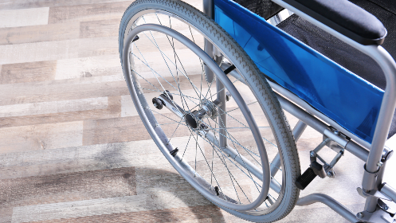
- Suppliers or doctors who charge for items you never received.
- Suppliers who bill for people who have passed away.
- Suppliers who request your Medicare number at a
presentation, during a sales pitch, or in an unsolicited phone call.
- Beneficiaries who willingly allow their Medicare number to
be used in exchange for money, gifts, or unnecessary equipment and supplies.
- Suppliers who deliver an off-the-shelf product but bill Medicare for a more costly product.

What Can You Do to Stop Durable Medical Equipment Fraud?
- Be sure your doctor has assessed your condition and orders the equipment or supplies.
- Never sign a blank form from your health care provider or equipment supplier.
- Always read your Medicare Summary Notice (MSN) or Explanation of Benefits (EOB). Look for charges for equipment you do not need, never requested, or did not receive.
- If you rent and return medical equipment, always get a dated receipt.
- Protect your Medicare, Medicaid, and Social Security cards like credit cards.
- Do not accept products or services from strangers who call or knock on your door.
- Do not give out your Medicare number at a presentation or during a sales pitch.
- Do not accept money, gifts, or unnecessary equipment and supplies from a supplier in exchange for your Medicare number.

Example Medicare Charges for DME
Any Medicare code that starts with an “L” indicates that it is an orthotic, which is a type of DME. Here are some examples:
- L0625-LO651: Lumbar Orthosis ~ Back brace
- L1810-L1860: Knee Orthosis ~ Knee brace
- L1900-L1990: Ankle-foot Orthosis ~ Ankle brace
- L3650-L3678: Shoulder Orthosis ~ Shoulder brace
- L3763-L3931: Wrist Orthosis ~ Wrist brace

How Can Your Senior Medicare Patrol (SMP) Help?
Your local SMP is ready to provide you with the information you need to PROTECT yourself from Medicare fraud, errors, and abuse; DETECT potential fraud, errors, and abuse; and REPORT your concerns. SMPs and their trained teams help educate and empower Medicare beneficiaries in the fight against health care fraud. Your SMP can help you with your questions, concerns, or complaints about potential fraud and abuse issues. It also can provide information and educational presentations.

To locate your local Senior Medicare Patrol (SMP), visit:
www.smpresource.org or call 1-877-808-2468.
This project was supported, in part, by grant number 90MPRC0002 from the U.S. Administration for Community Living, Department of Health and Human Services, Washington, D.C. 20201. Grantees undertaking projects under government sponsorship are encouraged to express freely their findings and conclusions. Points of view or opinions do not, therefore, necessarily represent official Administration for Community Living policy.

