Harm to Beneficiaries Case 1: Untreated Wound
10.11.21
Facebook Post: "When a beneficiary elects hospice care, the hospice is responsible for providing all services related to the beneficiary’s terminal illness and related conditions. When a hospice does not comply with Medicare requirements, there can be significant consequences for the beneficiary. Although these cases do not represent the majority of hospice beneficiaries or the majority of hospice providers, any instance of harm must be taken seriously," from @HHS Office of Inspector General.

To learn more about hospice fraud, errors, or abuse, visit https://smpresource.news/hospicefraud.

Note: Space was provided in the lower right side of the image for your state logo and contact information.Do not remove the national logo, citations, or grant statement.
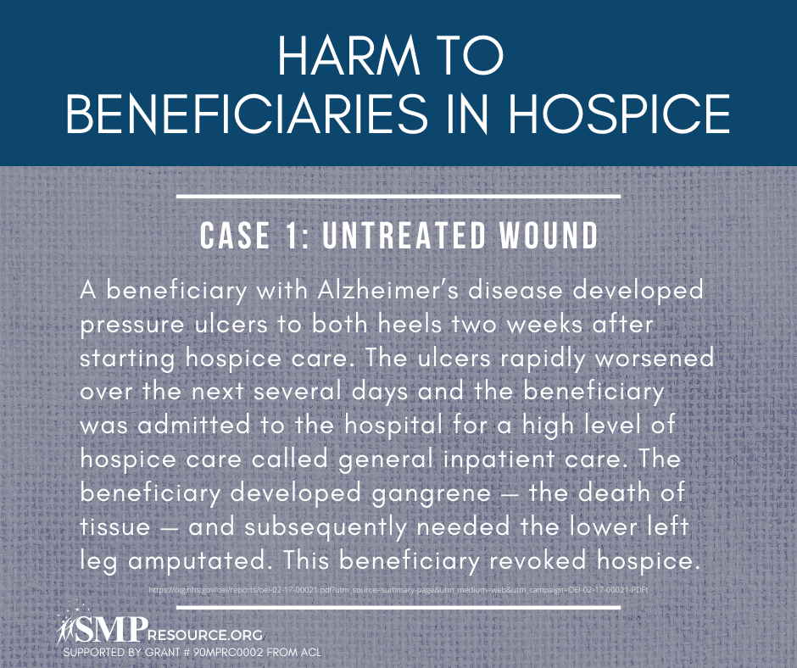

Twitter Post: While #hospice is an important benefit, sometimes there can be harm to beneficiaries. In this case, a wound went untreated and the beneficiary needed their leg amputated.
To learn more about hospice fraud, errors, or abuse, visit https://smpresource.news/hospicefraud.
#SeniorMedicarePatrol
Note: Space was provided in the lower right side of the image for your state logo and contact information.Do not remove the national logo, citations, or grant statement.
