Hospice Schemes - Offers
12.15.21
Facebook Post: Be on the lookout for hospice schemes that are on the rise. Review your Medicare statements for any charges that look suspicious. The #SeniorMedicarePatrol has been getting reports of beneficiaries signing up for offers, like supplies or Ensure shakes, while not realizing they are actually being tricked into signing up for hospice benefits.
This can be detrimental to a beneficiary who needs medical care as once they are on hospice, they cannot receive certain medical interventions. If you find that you have been signed up for hospice services against your will, please contact the SMP at 877.808.2468 or email info@smpresource.org.
Instagram Post: Be on the lookout for #hospice schemes that are on the rise. Review your Medicare statements for any charges that look suspicious. The #SeniorMedicarePatrol has been getting reports of beneficiaries signing up for offers, like supplies or Ensure shakes, while not realizing they are actually being tricked into signing up for hospice benefits.

This can be detrimental to a beneficiary who needs medical care as once they are on hospice, they cannot receive certain medical interventions. If you find that you have been signed up for hospice services against your will, please contact the #SMP at 877.808.2468 or email info@smpresource.org.

#Medicare #MedicareFraud #Tricked #scam #65andolder #preventdetectreport

Note: Space was provided in the bottom corner for your state logo and contact information. Do not remove the national logo, citations, or grant statement.
The below image is used for both Facebook and Instagram and can be scheduled to Instagram directly from Facebook Business Suite, if you would like.
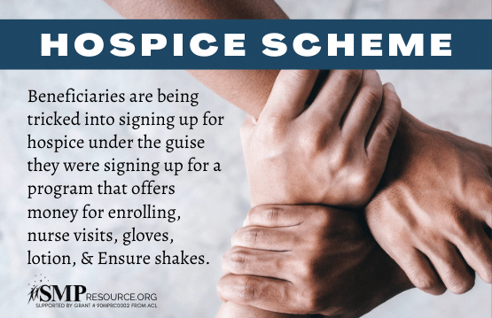

Twitter Post: Be on the lookout for #hospice schemes that are on the rise. Review your Medicare statements for any charges that look suspicious. If you find that you have been signed up for hospice services against your will, contact the #SMP at 877.808.2468 or email info@smpresource.org.
Note: Space was provided in the bottom corner for your state logo and contact information. Do not remove the national logo, citations, or grant statement.

