Medical Identity Theft Affects You
8.26.21
Facebook Post: How does medical identity theft really affect you? Here are just a few examples. Medicare fraud is a BIG deal. Protect yourself by learning more here: https://www.smpresource.org/Content/You-Can-Help.aspx.

Note: Space was provided on the right side for your state logo and contact information. Do not remove the national logo, citations, or grant statement.
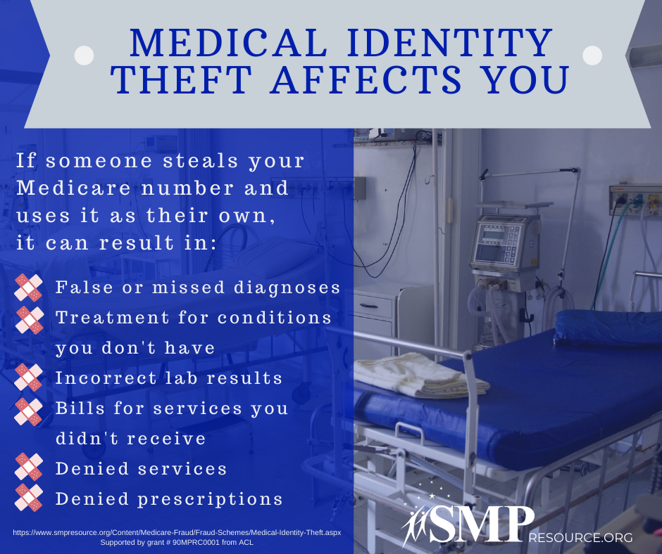

Twitter Post: How does #MedicalIdentityTheft really affect you? Here are just a few examples. #MedicareFraud is a BIG deal. Protect yourself by learning more here: https://www.smpresource.org/Content/You-Can-Help.aspx. #SeniorMedicarePatrol
Note: Space was provided on the right side for your state logo and contact information. Do not remove the national logo, citations, or grant statement.
