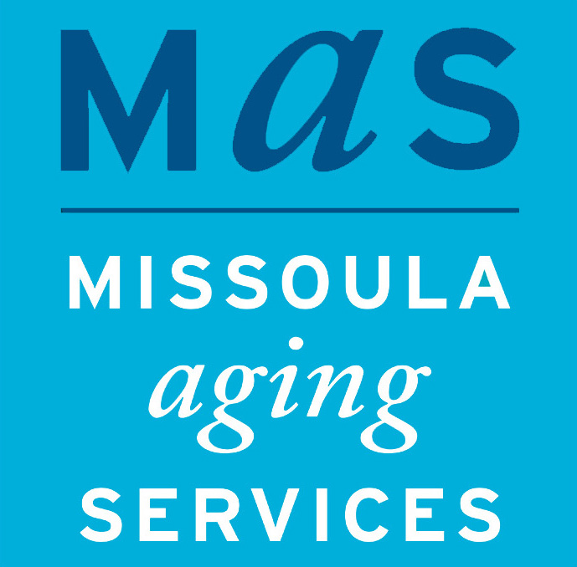

Jennifer Schultz
Communications Coordinator
Missoula Aging Services
(406) 728-7682
jschultz@missoulaagingservices.org

FOR IMMEDIATE RELEASE

NEW MEDICARE SCAMS TARGET TELEHEALTH

MISSOULA, MT (December 1, 2021) Multiple accounts of scam calls have been reported to Montana’s Senior Medicare Patrol (SMP), including new attempts to take advantage of Montanans’ increased use of telehealth during the pandemic. The current complaints document unsolicited phone calls people are receiving with the purpose of sending unnecessary medical supplies or stealing Medicare numbers. Those calls include “we need to confirm your Medicare number” and “you are eligible to receive a free genetic test kit.”

Telehealth fraud has increased along with the increased use of telehealth during the pandemic. Telehealth services include virtual office visits and certain medical services using two-way telecommunication systems like video, telephone, and email. If you don’t know who you are speaking to and they are inquiring about your medical needs, please hang up and consult your own provider.

If you receive a call from someone you don’t know claiming to be with Medicare or a provider who will bill Medicare and they request your personal information or would like to send you free medical/lab testing kits, including genetic or cardiovascular, please hang up and report this to Montana SMP at 1-800-551-3191.

Always read your Medicare Summary Notice for improper billing of items or services.
If you suspect telehealth fraud, address it immediately. If you receive an unsolicited phone call from someone wanting to verify your pain symptoms, family history, or medical illnesses including cardiovascular, genetics, or any cancer, or you receive unsolicited medical devices or test kits in the mail, please call your local Montana SMP at 1-800-551-3191.

About Missoula Aging Services:
Missoula Aging Services promotes the independence, dignity and health of older adults and those who care for them.

Missoula Aging Services was established in 1982 by the Missoula County Commissioners with a modest budget and a staff of five. Today, Missoula Aging Services empowers thousands of older adults, their families and caregivers through programs, services, volunteer opportunities and education to continue to live independently at home, for as long as possible.

Find out more: missoulaagingservices.org

