Medicare Open Enrollment Definition
11.8.21
Facebook and Instagram Post: Medicare Open Enrollment, #MedicareOE, is in full swing! Contact your local #SHIP through the SHIP National Technical Assistance Center for free, unbiased assistance in comparing plans.
Note: Space was provided along the bottom right for your state logo and contact information. Do not remove the national logo, citations, or grant statement.
The below image is used for both Facebook and Instagram and can be scheduled to Instagram directly from Facebook Business Suite, if you would like.
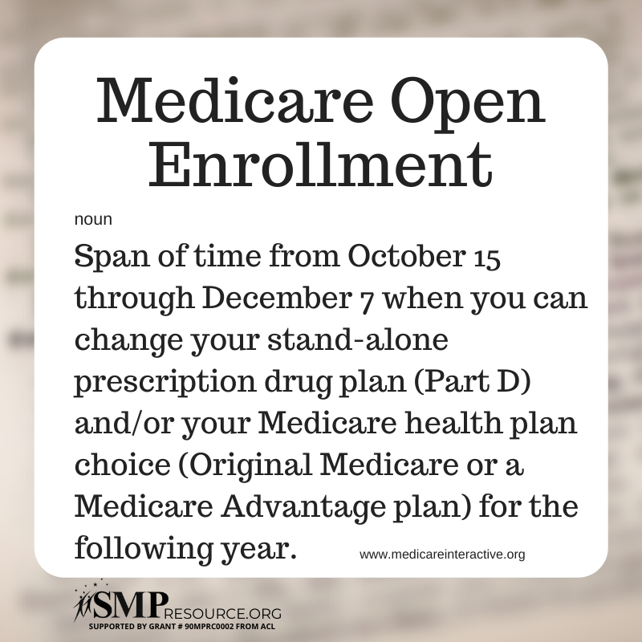

Twitter Post: Medicare Open Enrollment, #MedicareOE is in full swing! Contact your local #SHIP through the @SHIPTACenter for free, unbiased assistance in comparing plans.
Note: Space was provided along the bottom right for your state logo and contact information. Do not remove the national logo, citations, or grant statement.
