Medicare Open Enrollment Ends Today!
12.7.21
Facebook Post: Friendly reminder that today is the last day of Medicare Open Enrollment! Plans change year to year so make sure to review your options before time runs out. Contact your local SHIP through the @SHIPTA.
Instagram Post: Friendly reminder that today is the last day of Medicare Open Enrollment! Plans change year to year so make sure to review your options before time runs out. Contact your local SHIP through the SHIP National Technical Assistance Center at www.shiphelp.org. #MedicareOpenEnrollment #MedicareOE #SHIP
Note: Space was provided in the bottom corner for your state logo and contact information. Do not remove the national logo, citations, or grant statement.
The below image is used for both Facebook and Instagram and can be scheduled to Instagram directly from Facebook Business Suite, if you would like.
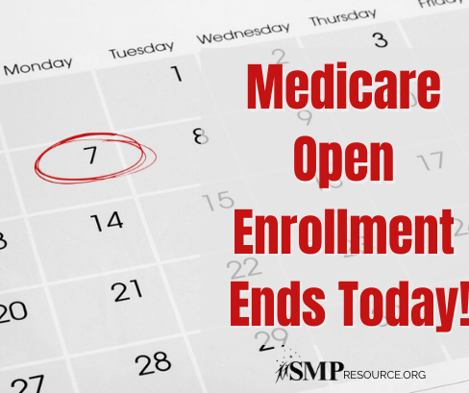

Twitter Post: Friendly reminder that today is the last day of Medicare Open Enrollment! Plans change year to year so make sure to review your options before time runs out. Contact your local SHIP through the @SHIPTA.
Note: Space was provided in the bottom corner for your state logo and contact information. Do not remove the national logo, citations, or grant statement.

