Medicare Open Enrollment Has Begun
10.15.21
Facebook Post: It's #MedicareOE time! If you would like assistance with reviewing different plans, you can use Medicare's Plan Finder or contact your local #SHIP through the SHIP National Technical Assistance Center.

Note: Space was provided in the lower left or right side of the image for your state logo and contact information.Do not remove the national logo, citations, or grant statement.
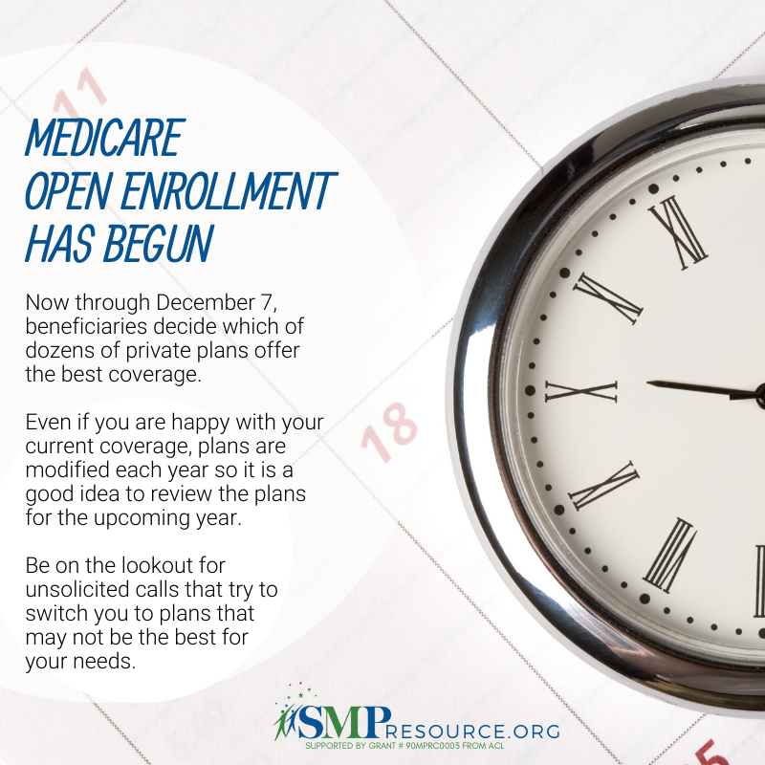

Twitter Post: It's #MedicareOE time! If you would like assistance with reviewing different plans, you can use Medicare's Plan Finder or contact your local #SHIP through the SHIP National Technical Assistance Center.
Note: Space was provided in the lower left and right side of the image for your state logo and contact information. Do not remove the national logo, citations, or grant statement.
