Protect Yourself Against COVID-19 Fraud
7.8.21
Facebook Post: Be aware of the latest scams about COVID-19 fraud and learn how to protect yourself here: https://smpresource.news/COVID-19.
Note: Space was provided in the lower right side for your state logo and contact information. Do not remove the national logo, citations, or grant statement.
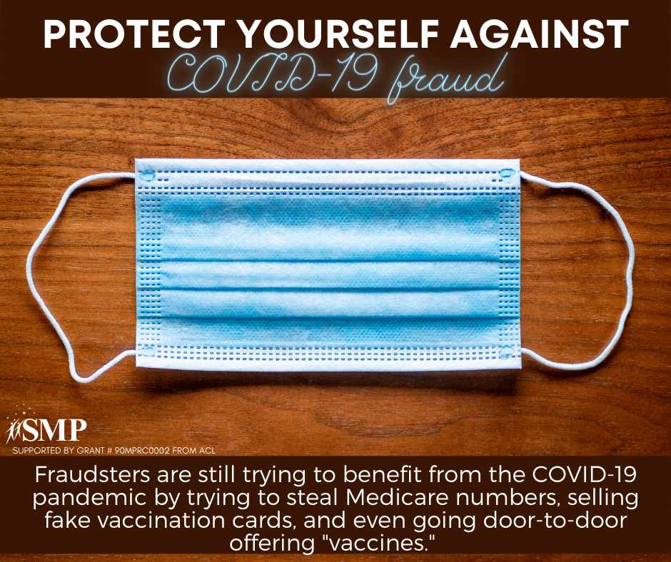

Twitter Post: Be aware of the latest scams about COVID-19 fraud and learn how to protect yourself here: https://smpresource.news/COVID-19.

Note: Space was provided in the upper right side for your state logo and contact information. Do not remove the national logo, citations, or grant statement.

