Protect Yourself Against: Nursing Home Fraud
6.21.21
Facebook Post:
What can you do to stop nursing home care fraud?
- Read your Medicare Summary Notice (MSN) or Explanation of Benefits (EOB) to compare the services Medicare was charged with what you received.
- Be sure you work with your doctor to enroll you in any skilled nursing facility (SNF) therapy services you may need and to determine medical necessity for these services.
- Do not accept gifts (such as money, gift cards, or groceries) in return for choosing a nursing home in which to receive skilled nursing.
- Do not sign forms that you do not understand, including a Medicare Outpatient Observation Notice (MOON), an Advance Beneficiary Notice (ABN), or any form that is blank.
- Report charges on your MSN or EOB for services or visits you did not receive.
- Report charges on your MSN or EOB for services that are different than what you received.
- Report quality-of-care complaints to your local SMP and the Beneficiary Family Centered Care Quality Improvement Organization (BFCC-QIO).
Contact the #SeniorMedicarePatrol to report nursing home care fraud.
Note: Space was provided ini the bottom right corner of the image for your state logo and contact information. Do not remove the national logo, citations, or grant statement.

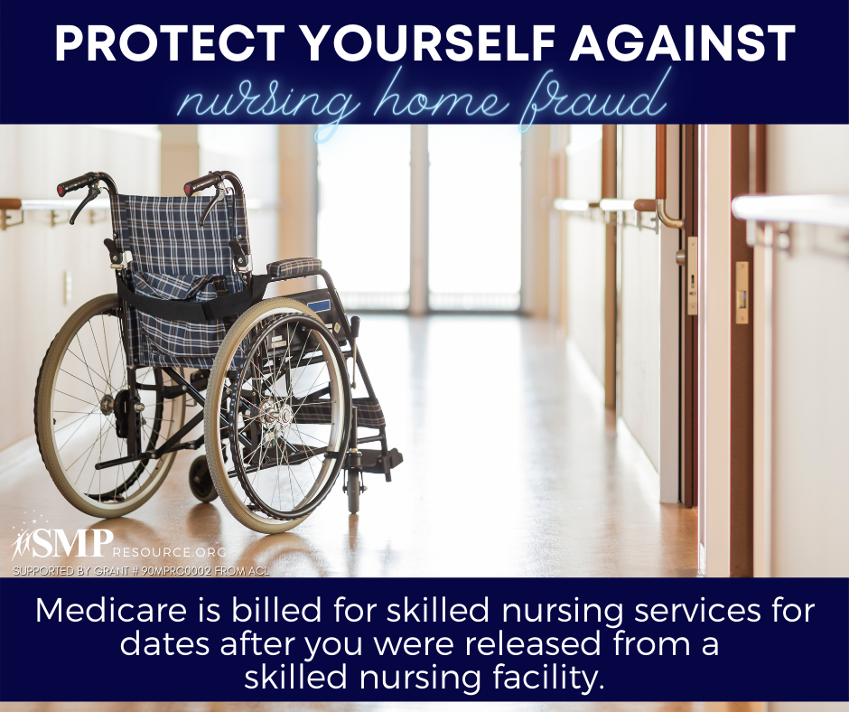

Twitter Post: What can you do to stop nursing home care fraud? Learn here:
Note: Space was provided ini the bottom right corner of the image for your state logo and contact information. Do not remove the national logo, citations, or grant statement.
