SMP Scam Watch Cardiac Genetic Testing
7.1.21
Facebook Post: Be aware of a new twist on an old scam.While genetic testing scams have been around for a few years, scammers have added cardiac genetic tests to the mix.
Please do not accept these unsolicited offers. If you receive calls about this or have received these kits, please report it to the #SeniorMedicarePatrol at 877-808-2468 or to info@smpresource.org. Note: Space was provided in the lower right corner for your state logo and contact information. Do not remove the national logo, citations, or grant statement.
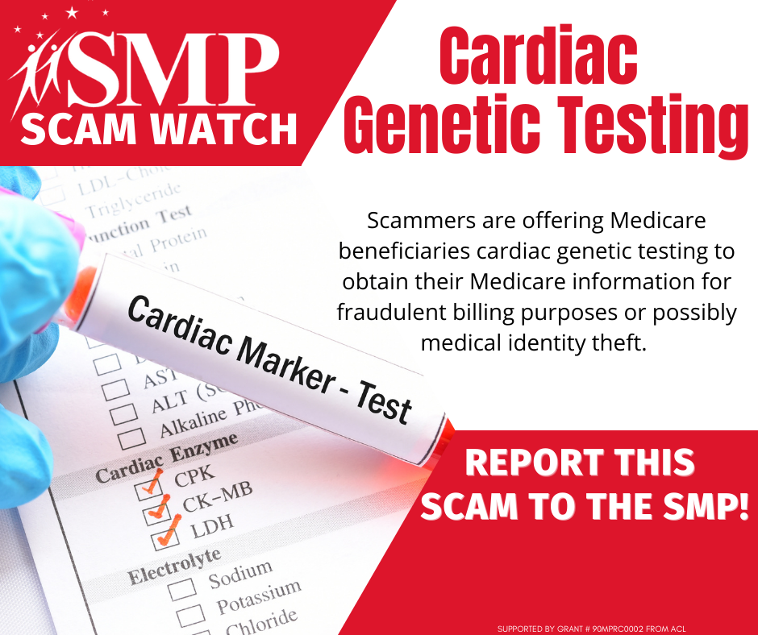

Twitter Post: Please do not accept these unsolicited offers for cardiac genetic testing. If you receive calls about #genetictesting or have received these kits, please report it to the #SeniorMedicarePatrol at 877-808-2468 or to info@smpresource.org.
Note: Space was provided in the lower portion of the blue box for your state logo and contact information. Do not remove the national logo, citations, or grant statement.

