SMP Scam Watch: COVID-19 Antiviral Drug
10.13.21
Facebook Post: SMP Scam Watch: COVID-19 Antiviral Drug Access. As new drugs are developed in relation to COVID-19, be on the lookout for scam artists using this opportunity to steal your information. If you are contacted about any type of antiviral drug for the treatment or cure of COVID-19, hang up and report it to the @HHS OIG or #SeniorMedicarePatrol.
Note: Space was provided in the lower middle area of the image for your state logo and contact information.Do not remove the national logo, citations, or grant statement.
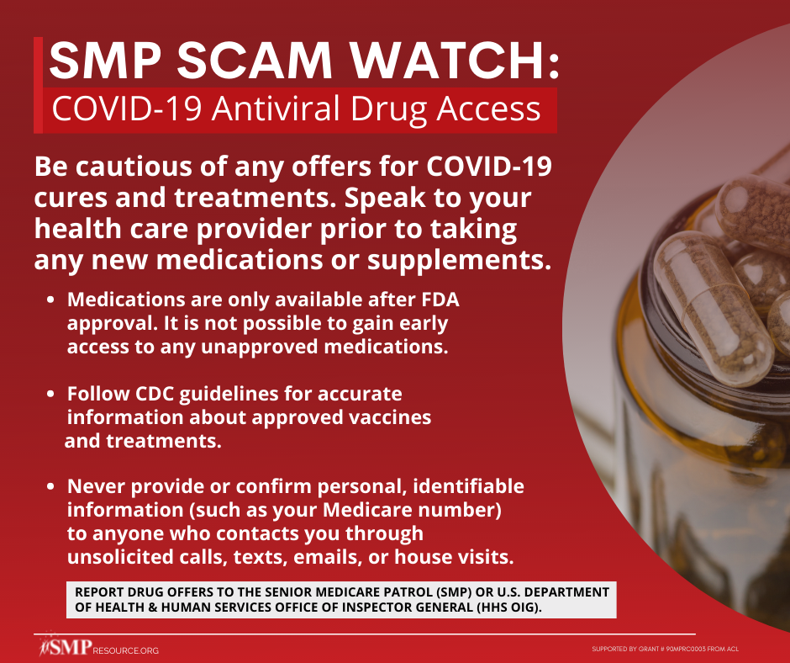

Twitter Post: As new drugs are developed in relation to #COVID19, be on the lookout for scam artists using this opportunity to steal your information. If you are contacted about any type of antiviral drug for the treatment or cure of COVID-19, report it to the @OIGatHHS or the #SMP.
Note: Space was provided in the lower middle area of the image for your state logo and contact information. Do not remove the national logo, citations, or grant statement.
