SMP Warning: Fake COVID-19 Test Sites
1.13.22
Facebook and Instagram Post: Be careful! Scammers are setting up fraudulent COVID-19 test sites in an effort to get your personal or medical information.
If you go to a pop-up site or other testing facility, research the facility or testing site before you go. The U.S. Food and Drug Administration has information at www.fda.gov.
If you are concerned you may have visited a fake testing site, contact the #SeniorMedicarePatrol by calling 877-808-2468 or HHS Office of Inspector General by calling 800-HHS-TIPS (800-447-8477).
Note: Space was provided in the bottom left corner for your state logo and contact information. Do not remove the national logo, citations, or grant statement.
The below image is used for both Facebook and Instagram and can be scheduled to Instagram directly from Facebook Business Suite, if you would like.
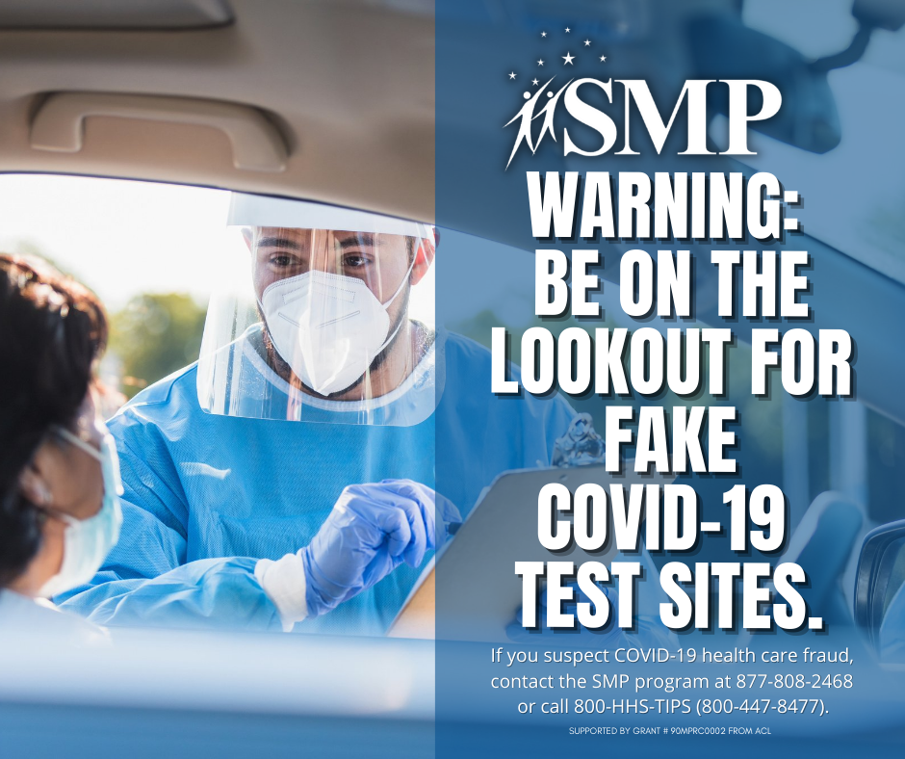
Twitter Post: #Scammers are setting up fraudulent #COVID19 test sites in an effort to get your personal or medical information. If you are concerned you may have visited a fake testing site, contact the #SeniorMedicarePatrol at 877-808-2468 or @OIGatHHS at 800-HHS-TIPS (800-447-8477).
Note: Space was provided in the bottom left corner for your state logo and contact information. Do not remove the national logo, citations, or grant statement.
