Scammers Are Calling: Braces
10.25.21
Facebook Post: Scammers are calling beneficiaries saying they are from Medicare, or work with Medicare, and that the beneficiary has qualified for a brace: back, knee, wrist, etc. The caller may have a lot of personal identifying information like the beneficiary's name, address, and even date of birth.

Scammers want the beneficiary to confirm they have pain and to provide their Medicare number so the scammer can send a brace, even if the beneficiary doesn't want or need it.

If you get a call that sounds like this, you can ask who is calling, try to get a phone number to call back, or simply hang up.

Note: Space was provided in the lower left or right side of the image for your state logo and contact information.Do not remove the national logo, citations, or grant statement.
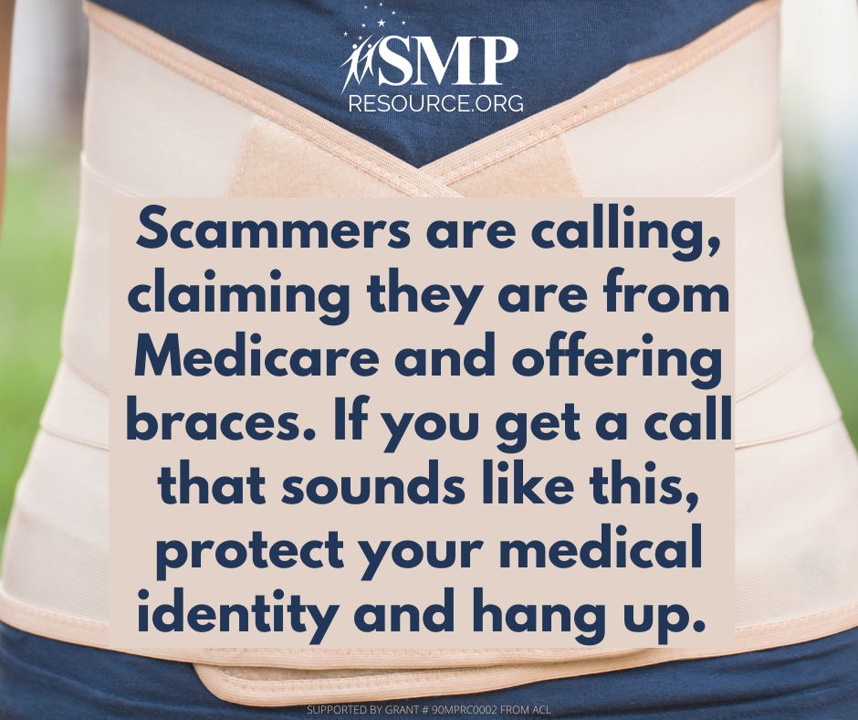

Twitter Post: Scammers are calling beneficiaries saying they are from Medicare and that the beneficiary has qualified for a brace. The caller may have a lot of personal identifying information. Contact the #SeniorMedicarePatrol to report braces you don't want or didn't order.
Note: Space was provided in the lower left or right side of the image for your state logo and contact information. Do not remove the national logo, citations, or grant statement.
