Treating Physician
6.9.21
Facebook Post: "When you think of a treating physician, who do you think of? Probably not a person you met at a health fair or who found you on social media. Genetic, cancer, and/or DNA testing need to be ordered by YOUR treating physician.
If you receive offers for ""free"" genetic testing, report them to your local #SeniorMedicarePatrol at 1-877-808-2468. Learn more about genetic testing fraud here: https://smpresource.news/genetic-testing-fraud."
Note: Space was provided in the bottom right corner for your state logo and contact information. Do not remove the national logo, citations, or grant statement.
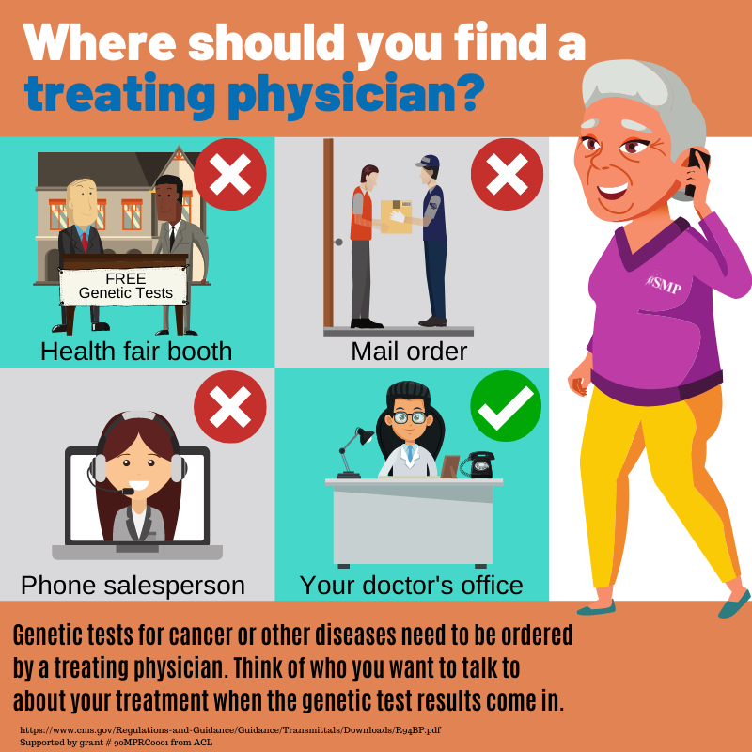
Twitter Post: "Genetic, cancer, and/or DNA testing need to be ordered by YOUR treating physician.
If you receive offers for ""free"" genetic testing, report them to your local #SeniorMedicarePatrol at 1-877-808-2468."
Note: Space was provided in the bottom right corner for your state logo and contact information. Do not remove the national logo, citations, or grant statement.
