Vaccine Verification Scam
3.2.22
Facebook and Instagram Post: The SMP is hearing about an increasing number of vaccine verification scams. These may come in via text, email, or call, and ask for individuals to verify their vaccination status as well as a number of other personal health details. If you have given out your Medicare number over the phone, text, or email, please report it to the #SeniorMedicarePatrol in your state. Find your SMP by visiting www.smpresource.org.
Note: Space was provided along the bottom for your state contact information. Do not remove the national logo, citations, or grant statement.
The below image is used for both Facebook and Instagram and can be scheduled to Instagram directly from Facebook Business Suite, if you would like.
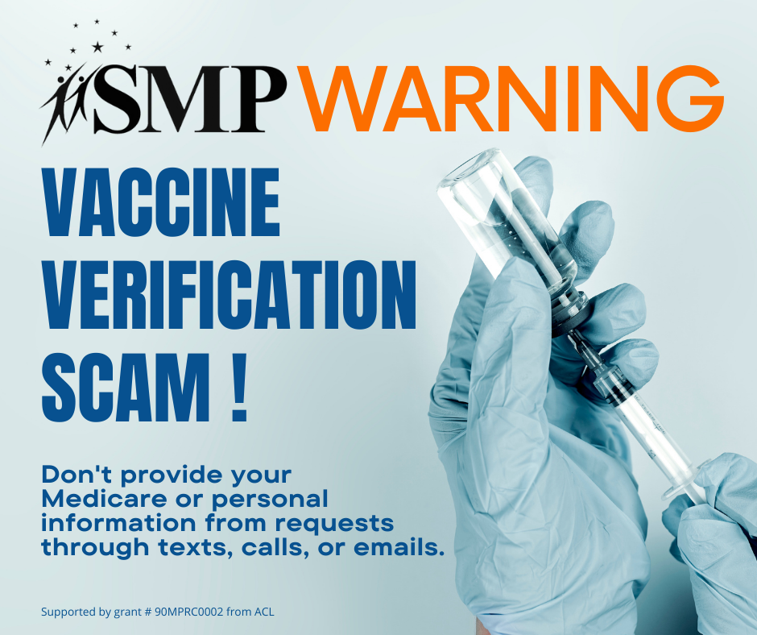

Twitter Post: Prescription drug fraud is a consistent trend in #Medicare due to the lucrative nature of prescription drug diversion and pharmacy scams.
To report potential pharmacy and prescription drug fraud, contact your #SeniorMedicarePatrol at 877-808-2468.
Note: Space was provided along the bottom for your state contact information. Do not remove the national logo, citations, or grant statement.
