Your Doctor Didn’t Ask - Cardiac
9.9.21
Facebook Post: You might get a call, if you haven't already, saying you may qualify for a cardiac genetic test if you answer a few questions. They may also offer "free" braces. They will probably say it is approved by Medicare or that your doctor has requested they call. The truth is, none of this is true. If you are concerned about your heart, your genetic markers, or have pain requiring a brace, you should work with your primary care physician and not someone cold calling. These calls are likely scammers trying to get your Medicare number to bill Medicare. If you have given out your Medicare number, contact the Senior Medicare Patrol today at 877.808.2468.

Learn more about the opioid epidemic here: https://www.hhs.gov/opioids/about-the-epidemic/index.html.

Note: Space was provided along the right for your state logo and contact information. Do not remove the national logo, citations, or grant statement.
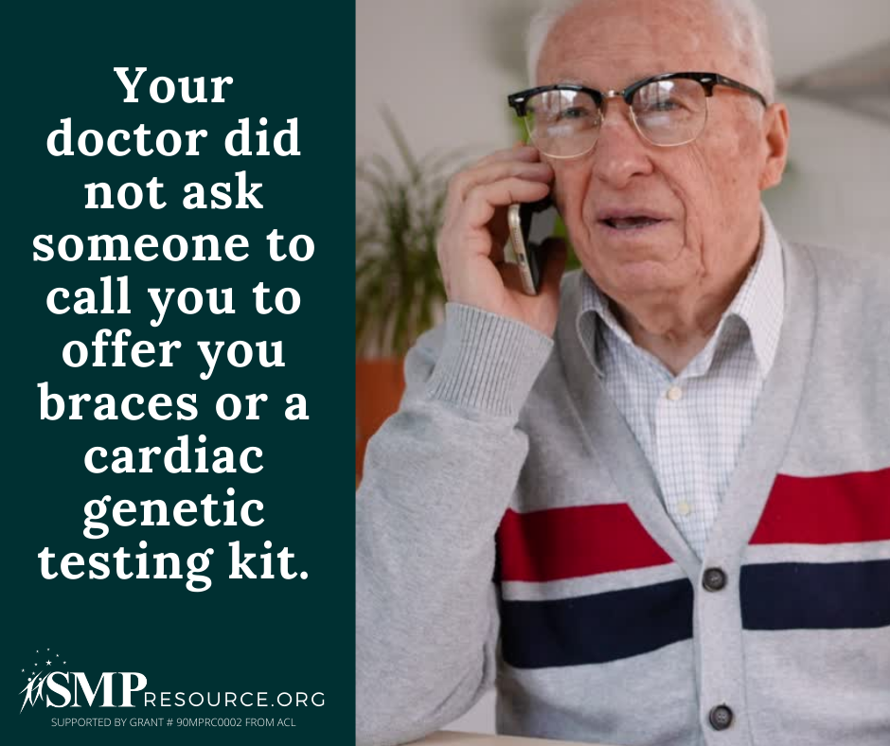

Twitter Post: You might get a call, if you haven't already, saying you may qualify for a cardiac genetic test if you answer a few questions. These calls are likely scammers trying to get your Medicare number. If you have given out your Medicare number, contact the #SeniorMedicarePatrol.
Note: Space was provided in the bottom left corner for your state logo and contact information. Do not remove the national logo, citations, or grant statement.
