BOLO Brace Scams
6.1.21
Facebook Post: Have you received a call about qualifying for "free" back braces through Medicare? Or worse yet, have you actually had braces mailed to you and you aren't sure how or why?
Scam artists are calling Medicare beneficiaries, pretending to work with Medicare or their doctor stating they qualify for a brace. They just need the beneficiary to confirm their Medicare number. They then ship braces, sometimes in bulk, to the beneficiary. This can be a nightmare situation.
If you know someone who has Medicare, make sure they know about this brace scam.
Note: Space was provided in the lower part of the blue box for your state logo and contact information. Do not remove the national logo, citations, or grant statement
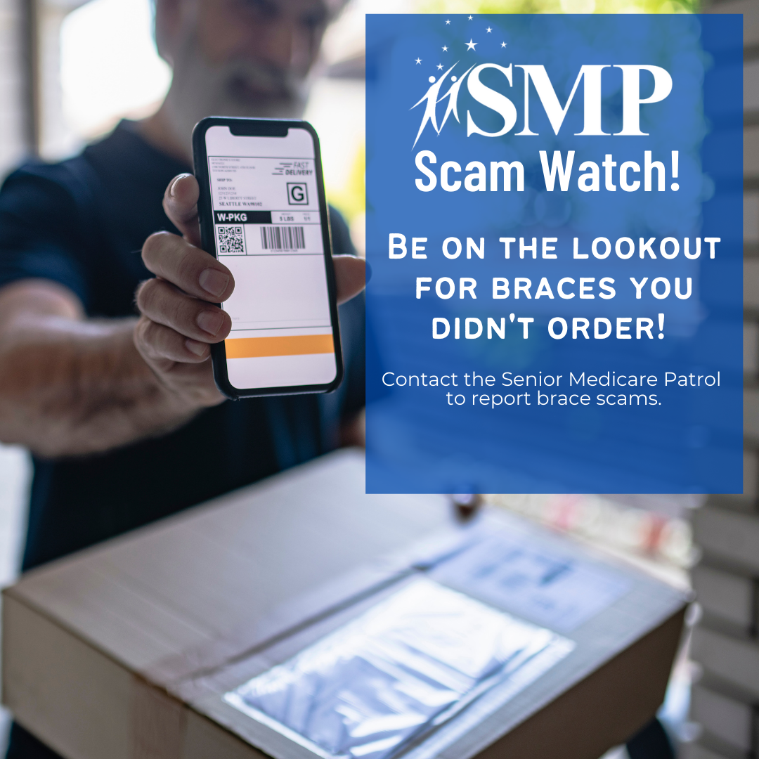
Twitter Post: #BOLO Scam artists are calling Medicare beneficiaries, pretending to work with Medicare or their doctor stating they qualify for a brace. #SMPscamWatchDME #MedicareFraud
Note: Space was provided in the lower portion of the blue box for your state logo and contact information. Do not remove the national logo, citations, or grant statement.

