Glucose Monitors
4.27.22
Facebook Post: The SMP has been hearing about calls regarding glucose monitors. If you get a call offering a glucose monitor, it is best to hang up. If you need a glucose monitor or any other kind of health care, contact your doctor.
Instagram Post: The SMP has been hearing about calls regarding glucose monitors. If you get a call offering a glucose monitor, it is best to hang up. If you need a glucose monitor or any other kind of health care, contact your doctor.

#SeniorMedicarePatrol #SMP #GlucoseMoniter #Diabetes #Medicare #FraudAlert #ScamWarning

Note: Space was provided in the bottom right corner for your state contact information. Do not remove the national logo, citations, or grant statement.

The below image is used for both Facebook and Instagram and can be scheduled to Instagram directly from Facebook Business Suite, if you would like.
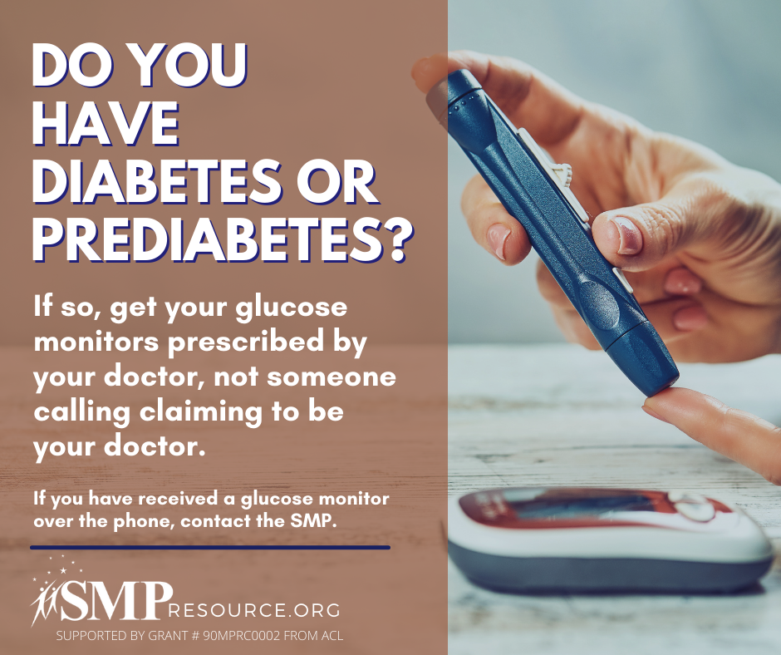

Twitter Post: The SMP has been hearing about calls regarding glucose monitors. If you get a call offering a glucose monitor, it is best to hang up. If you need a glucose monitor or any other kind of health care, contact your doctor.
Note: Space was provided in the bottom right corner for your state contact information. Do not remove the national logo, citations, or grant statement.
