Protect Yourself & Medicare
Posted 5.17.21
Facebook Post: Medical identity (ID) theft occurs when someone steals personal information – such as a beneficiary’s name and Medicare number – and uses the information to get medical treatment, medical equipment, prescription drugs, surgery, or other services and then bills insurance (such as Medicare) for it.
Medical identity theft can also affect a beneficiary's medical and health insurance records. Every time a scammer uses a beneficiary’s identity to receive or bill for care/supplies, a record is created with incorrect medical information about them.
Learn more about medical identity theft and how to report it here: https://smpresource.news/medical-identity-theft
Note: Space was provided in the bottom right corner for your state logo and contact information. Do not remove the national logo, citations, or grant statement.

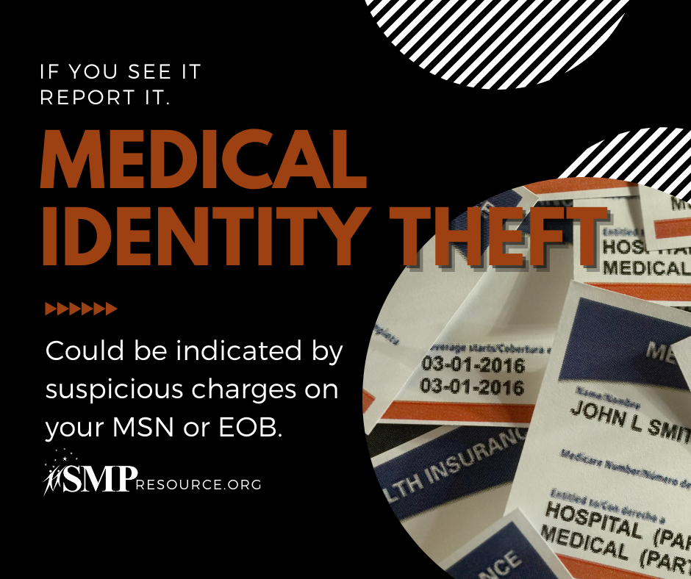

Twitter Post: Every time a scammer uses a beneficiary’s identity to receive or bill for care/supplies, a record is created with incorrect medical information about them.
Learn more about #medicalidentitytheft and how to report it here: https://smpresource.news/medical-identity-theft
Note: Space was provided in the bottom left corner for your state logo and contact information. Do not remove the national logo or grant statement.
