If You See It Report It Marketing Violations
11.15.21
Facebook and Instagram Post: During this Medicare Open Enrollment, #MedicareOE, be on the lookout for marketing violations. An example would be if an agent initiates a discussion about other insurance products, such as life insurance annuities, during a visit or meeting about a Part C or Part D Medicare product.
If this happens, contact your local #SeniorMedicarePatrol by calling 877.808.2468 or emailing info@smpresource.org.
Note: Space was provided along the top right for your state logo and contact information. Do not remove the national logo, citations, or grant statement.
The below image is used for both Facebook and Instagram and can be scheduled to Instagram directly from Facebook Business Suite, if you would like.

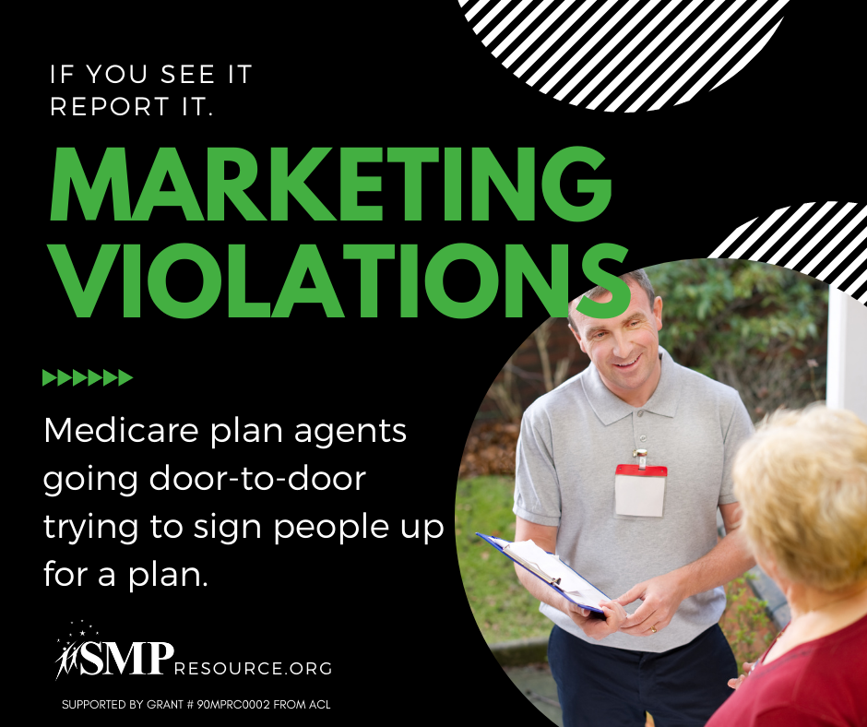
Twitter Post: During this #MedicareOE, be on the lookout for marketing violations. An example would be if an agent initiates a discussion about other insurance products during a visit or meeting about a Part C or D Medicare product. If this happens, contact your local #SeniorMedicarePatrol.
Note: Space was provided along the top right for your state logo and contact information. Do not remove the national logo, citations, or grant statement.
