If You See It Report It: Drug Diversion
6.29.21
Facebook Post: When you pick up a prescription for yourself or a loved one, make sure to count your pills when you get home. If you are shorted pills, it could be an accident or it could be something more. To report possible drug diversion fraud, contact your #SeniorMedicarePatrol at 877-808-2468 or email info@smpresource.org.
Note: Space was provided in the top right for your state logo and contact information. Do not remove the national logo, citations, or grant statement.
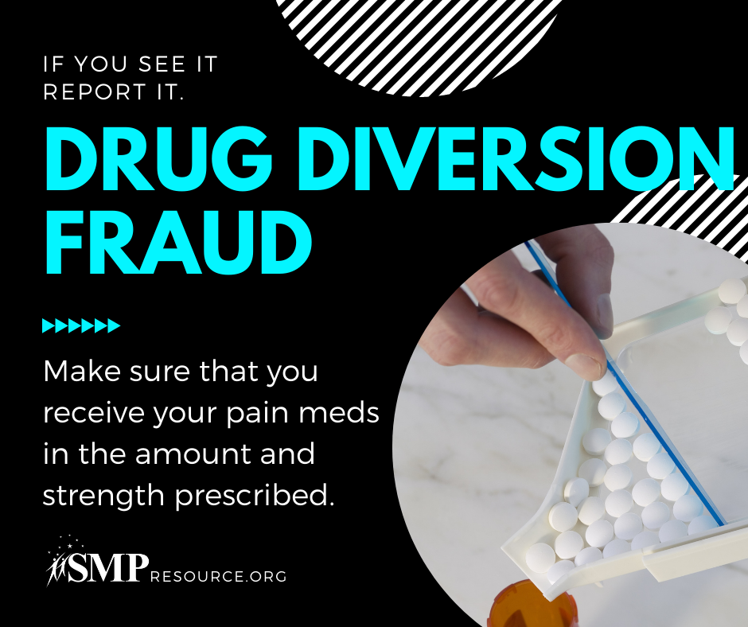

Twitter Post: If you are shorted pills, it could be an accident or it could be something more. To report possible drug diversion fraud, contact your #SeniorMedicarePatrol at 877-808-2468 or email info@smpresource.org.
Note: Space was provided in the top right for your state logo and contact information. Do not remove the national logo, citations, or grant statement.
