Medicare Open Enrollment Ends Tomorrow!
12.6.21
Facebook Post: Friendly reminder that tomorrow is the last day of Medicare Open Enrollment! This is the time to review and change your Medicare plans. Once this closes, you will need to wait until next year's open enrollment. Visit shiphelp.org or medicare.gov to learn more.
Instagram Post: Friendly reminder that tomorrow is the last day of Medicare Open Enrollment! This is the time to review and change your Medicare plans. Once this closes, you will need to wait until next year's open enrollment. Visit shiphelp.org or medicare.gov to learn more. #Medicare #medicareopenenrollment #MOE #reminder #SHIP #Medicarehelp #SMP
Note: Space was provided in the bottom left corner for your state logo and contact information. Do not remove the national logo, citations, or grant statement.
The below image is used for both Facebook and Instagram and can be scheduled to Instagram directly from Facebook Business Suite, if you would like.

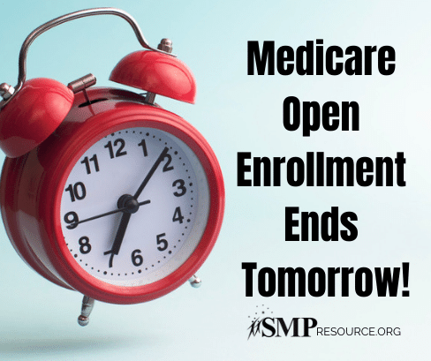

Twitter Post: Friendly reminder that tomorrow is the last day of Medicare Open Enrollment! This is the time to review and change your Medicare plans. Visit shiphelp.org or medicare.gov to learn more. #Medicare #MedicareOE #reminder #SHIP #SeniorMedicarePatrol
Note: Space was provided in the bottom left corner for your state logo and contact information. Do not remove the national logo, citations, or grant statement.
