Prescription Drug Fraud
3.1.22
Facebook Post: Pharmacy and prescription drug fraud is a consistent trend in Medicare. Due to the lucrative nature of prescription drug diversion and pharmacy scams, criminals continue to exploit Medicare Part D. Although there are many types of prescription drug schemes, pharmacy fraud primarily occurs when Medicare is billed for a medication that was not received or a beneficiary is intentionally given a different prescription drug than was prescribed.
To report potential pharmacy and prescription drug fraud, contact your #SeniorMedicarePatrol at 877-808-2468.
Instagram Post: #Pharmacy and #prescription drug fraud is a consistent trend in #Medicare. Due to the lucrative nature of prescription drug diversion and pharmacy scams, criminals continue to exploit Medicare Part D. Although there are many types of prescription drug schemes, pharmacy fraud primarily occurs when Medicare is billed for a medication that was not received or a beneficiary is intentionally given a different prescription drug than was prescribed.
To report potential pharmacy and prescription drug fraud, contact your #SeniorMedicarePatrol at 877-808-2468.
Note: Space was provided in the bottom right corner for your state contact information. Do not remove the national logo, citations, or grant statement.
The below image is used for both Facebook and Instagram and can be scheduled to Instagram directly from Facebook Business Suite, if you would like.
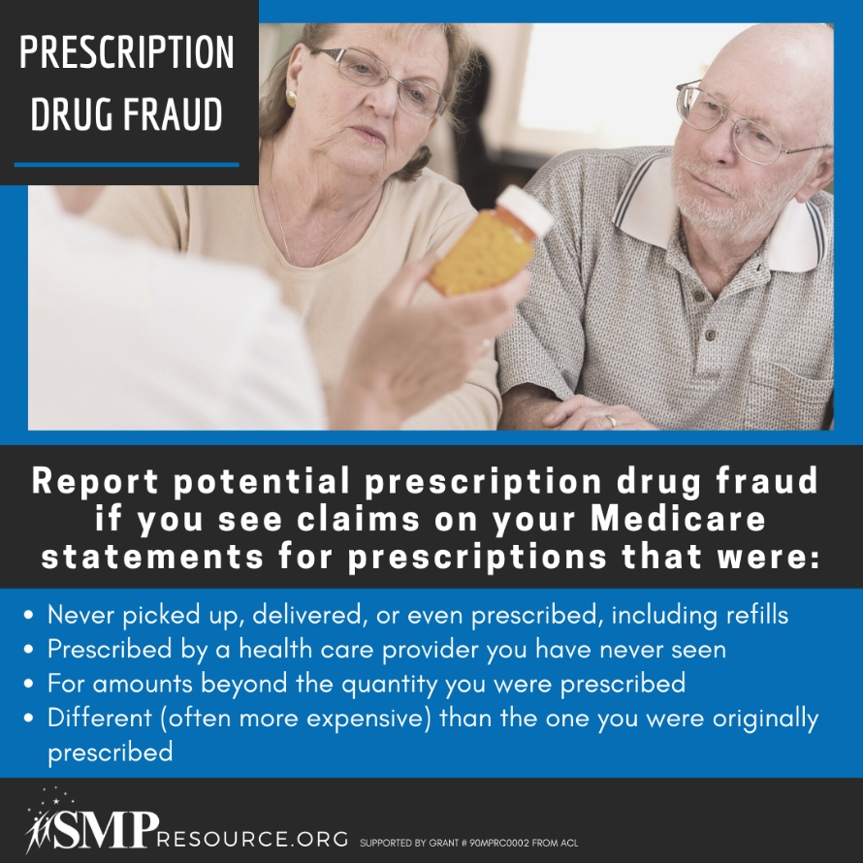
Twitter Post: Prescription drug fraud is a consistent trend in #Medicare due to the lucrative nature of prescription drug diversion and pharmacy scams.
To report potential pharmacy and prescription drug fraud, contact your #SeniorMedicarePatrol at 877-808-2468.
Note: Space was provided in the bottom right corner for your state contact information. Do not remove the national logo, citations, or grant statement.
