Protect Yourself Against: Home Health Care Fraud
10.7.21
Facebook Post: Report potential home health care fraud, errors, or abuse if:
*You see on your Medicare Summary Notice (MSN) or Explanation of Benefits (EOB) charges for:
-Home health services when you did not meet Medicare’s “homebound” criteria
-Services that were not deemed medically necessary by your doctor
-Home health services like skilling nursing care and/or therapy services that were not provided

*You were:
-Enrolled in home health services by a doctor you do not know
-Offered things such as “free” groceries or a “free” ride from a home health agency in exchange for your Medicare number or to switch to a different home health agency
-Charged a copayment for home health services
-Asked to sign forms verifying that home health services were provided even though you did not receive any services

*Someone came to your home and provided housekeeping or medication services, but you see on your Medicare Summary Notice (MSN) or Explanation of Benefits (EOB) that Medicare was billed for a covered service like skilled nursing or other therapy instead.
*You accept cash or gifts in exchange for going along with a home health scam.

Report suspected home health care fraud to the #SeniorMedicarePatrol at 877.808.2468 or email info@smpresource.org.
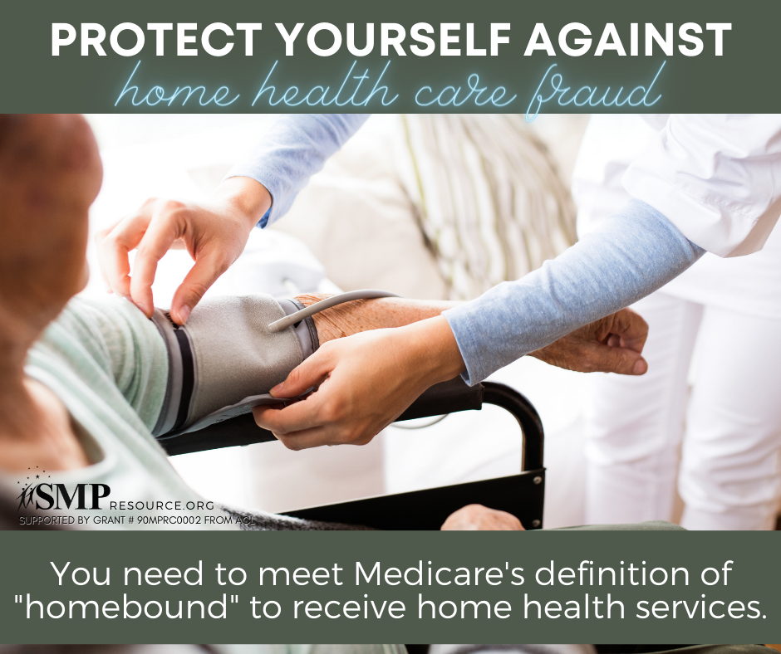
Note: Space was provided on the right side of the image for your state logo and contact information.Do not remove the national logo, citations, or grant statement.

Twitter Post: Report suspected home health care fraud to the #SeniorMedicarePatrol at 877.808.2468 or email info@smpresource.org. Learn more: https://smpresource.news/homehealthcarefraud
Note: Space was provided on the right side of the image for your state logo and contact information.Do not remove the national logo, citations, or grant statement.
