Protect Yourself Against Prescription Drug Fraud
Posted 5.11.21
Facebook Post: Pharmacy and prescription drug fraud is a consistent trend in Medicare. Due to the lucrative nature of prescription drug diversion and pharmacy scams, criminals continue to exploit Medicare Part D.
Although there are many types of prescription drug schemes, pharmacy fraud primarily occurs when Medicare is billed for a medication that was not received or a beneficiary is intentionally given a different prescription drug than was prescribed.
Learn more about what to look for and how to protect yourself here: https://smpresource.news/PharmacyandPrescriptionDrugFraud
Note: Space was provided in the bottom right corner for your state logo and contact information. Do not remove the national logo, citations, or grant statement.
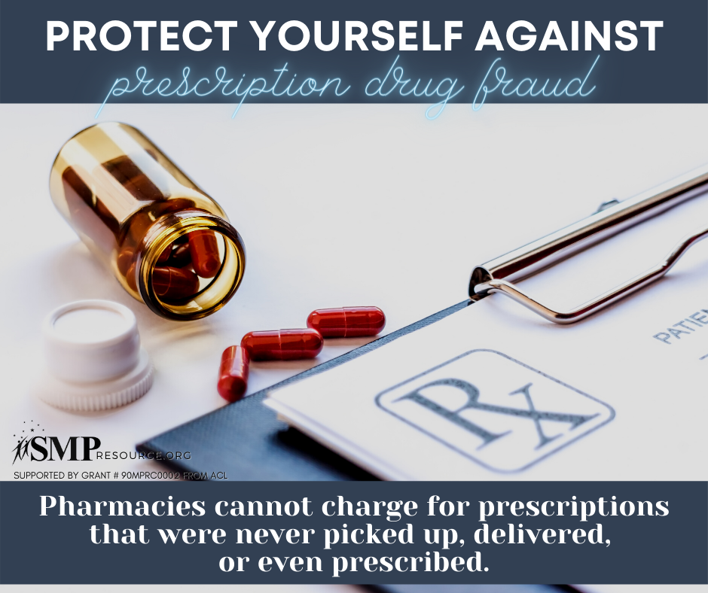

Twitter Post: Pharmacy fraud primarily occurs when Medicare is billed for a medication that was not received or a beneficiary is intentionally given a different prescription drug than was prescribed. Learn more: https://smpresource.news/PharmacyandPrescriptionDrugFraud
Note: Space was provided in the bottom right corner for your state logo and contact information. Do not remove the national logo or grant statement. 