Protect Yourself from Medicare Open Enrollment Fraud
11.10.21
Facebook: ⚠️Have you received an unsolicited phone call from someone claiming they were working with Medicare or others wanting to sell or change your Medicare plan?
⚠️Has someone come to your door with leaflets or other marketing materials about different Medicare plans?
⚠️Be on the lookout for any packets in the mail welcoming you to a new plan. If you get a packet like this, your plan was likely switched without you realizing this. Contact the Senior Medicare Patrol to report this. Call 877-808-2468 or email info@smpresource.org.
If you need assistance with finding the best Medicare plan for you, contact your local SHIP National Technical Assistance Center #SHIP.
Instagram Post: N/A
Note: Space was provided along the bottom right for your state logo and contact information. Do not remove the national logo, citations, or grant statement.
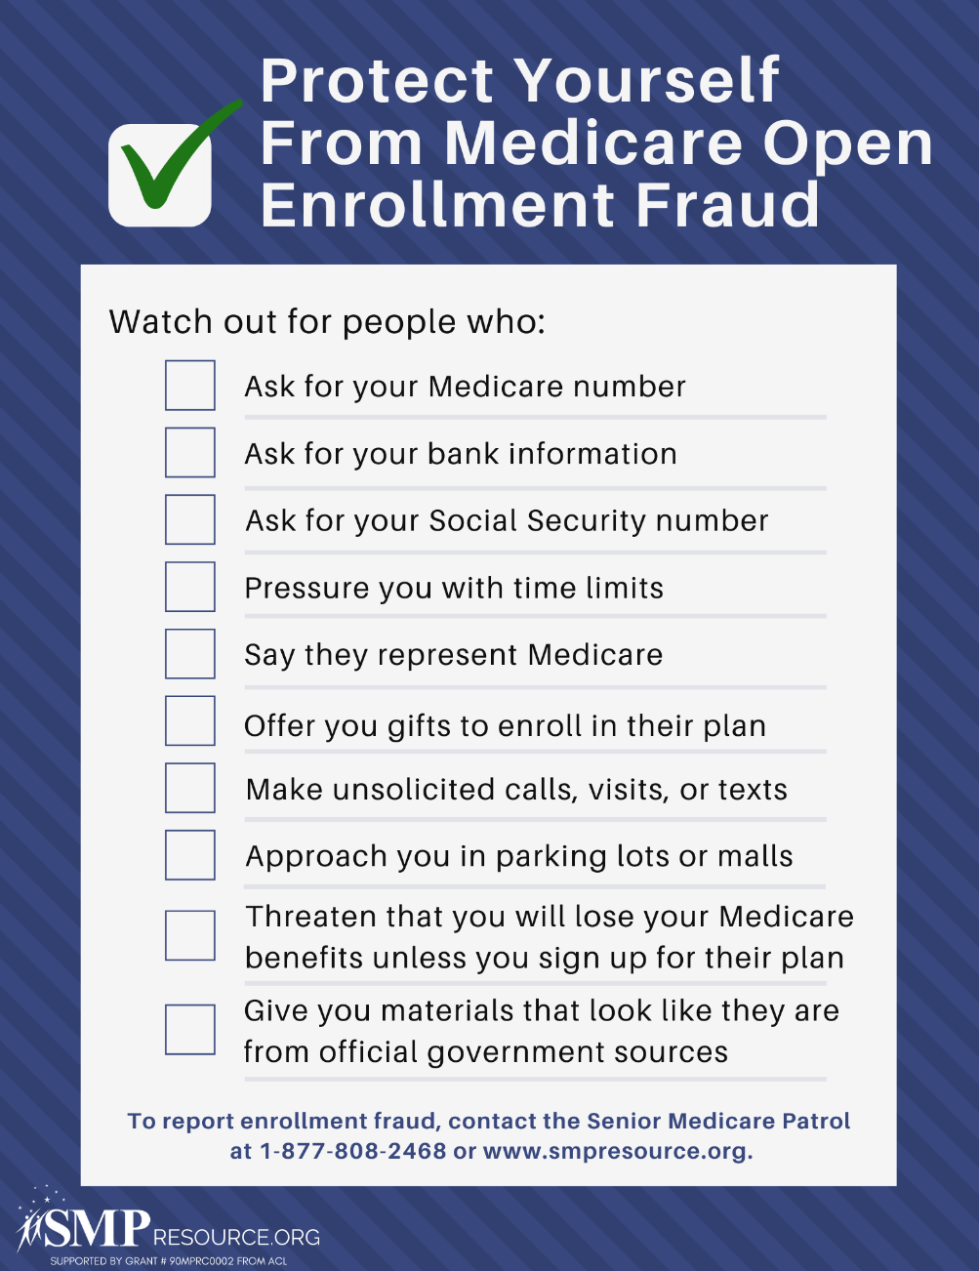

Twitter Post: Be on the lookout for any packets in the mail welcoming you to a new Medicare plan. If you get a packet like this, your plan was likely switched without you realizing this. Contact the #SeniorMedicarePatrol to report this. Call 877-808-2468 or email info@smpresource.org.
Note: Space was provided along the bottom middle for your state logo and contact information. Do not remove the national logo, citations, or grant statement.
