Providers Charging for COVID-19 Vaccine
6.14.21
Facebook Post: Did you have to pay for your COVID-19 vaccine? If so, that was fraud. If you are a Medicare recipient and paid for a COVID-19 vaccine, report it to the @OIG or #SeniorMedicarePatrol immediately.
Note: Space was provided in the bottom right corner for your state logo and contact information. Do not remove the national logo, citations, or grant statement.

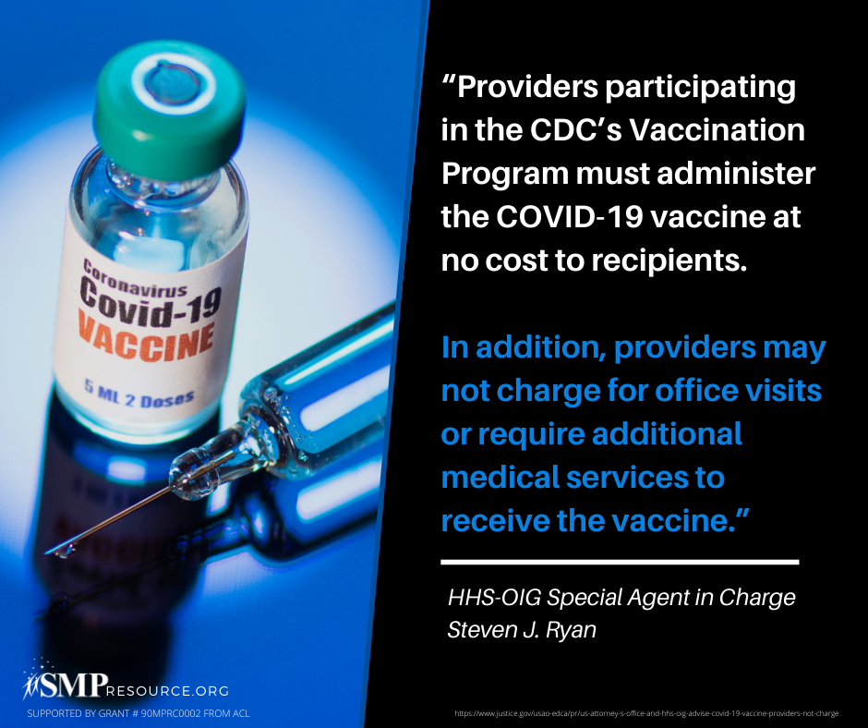

Twitter Post: Did you have to pay for your COVID-19 vaccine? If so, that was fraud. If you are a Medicare recipient and paid for a COVID-19 vaccine, report it to the @OIG or #SeniorMedicarePatrol immediately.
Note: Space was provided in the bottom right corner for your state logo and contact information. Do not remove the national logo, citations, or grant statement.

