Reading Your MSN Can Be Hard
7.12.21
Facebook Post: One of the best ways to detect Medicare fraud, errors, or abuse is by reading your Medicare Summary Notice (MSN). Your MSN comes in the mail every three months or can be located online by creating an account at medicare.gov.
Looking for things that you know you didn't receive, like braces, can be a way to detect fraud or errors.
To learn more about reading your MSN, visit https://smpresource.news/ReadMSN.
Note: Space was provided in the lower right side for your state logo and contact information. Do not remove the national logo, citations, or grant statement.
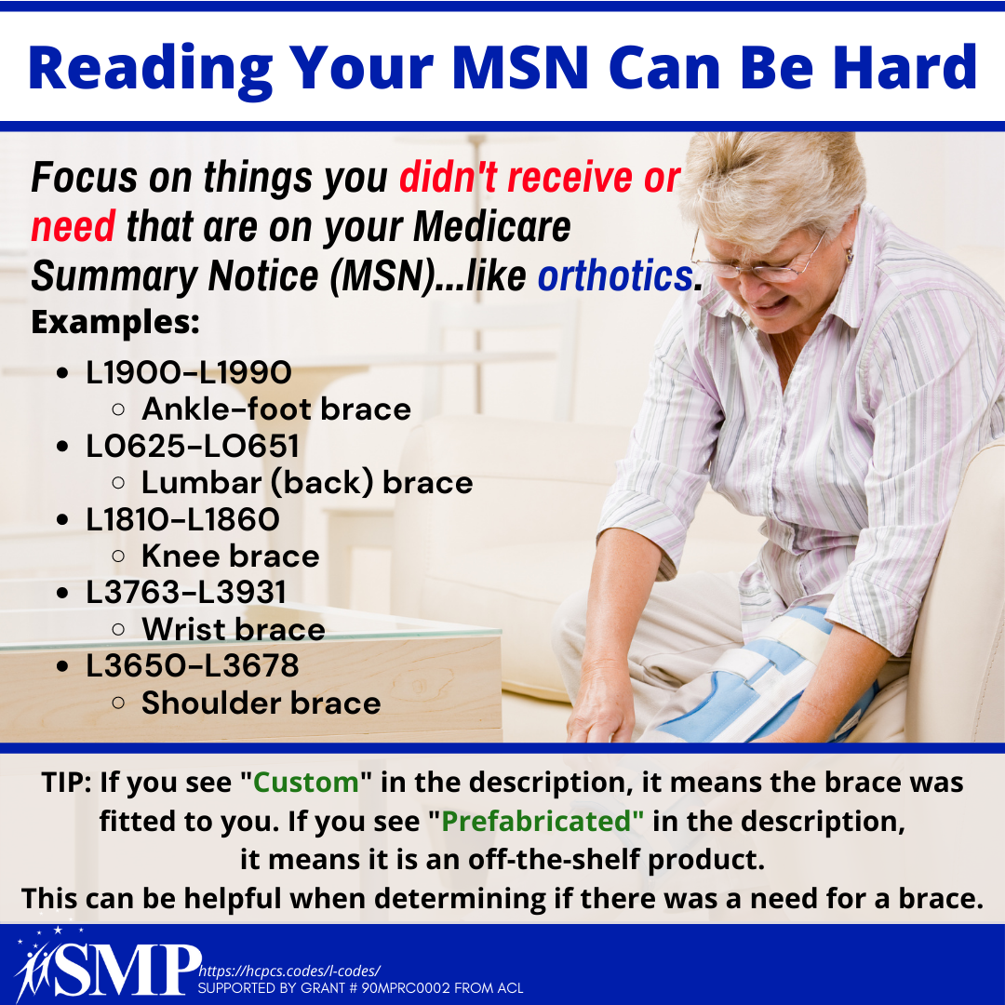
Twitter Post: One of the best ways to detect #Medicare fraud, errors, or abuse is by reading your Medicare Summary Notice (MSN) that comes in the mail every 3 months or online by creating an account at http://medicare.gov. Report Medicare fraud to the #SeniorMedicarePatrol.

Note: Space was provided in the lower right side for your state logo and contact information. Do not remove the national logo, citations, or grant statement.

