Report Home Health Care Fraud Day
11.6.21
Facebook and Instagram Post: Today is National Report Home Health Care Fraud Day. In common home health care fraud schemes, no actual home health therapy is provided. The beneficiary is asked to sign forms that verify a nurse or therapist showed up at the home and provided services when they didn't.
Unscrupulous physicians may also fraudulently certify that a beneficiary is homebound. In exchange, the beneficiary could be offered cash or provided a home health aide who prepares meals or cleans, which are services that are not covered by Medicare.
Billing Medicare for services not provided is highly illegal and you should report this immediately if you are approached for this scam.
Be cautious when you are offered money or "free" services in exchange for your Medicare card number. To report home health care fraud, contact your local #SeniorMedicarePatrol.
Note: Space was provided along the bottom left or right for your state logo and contact information. Do not remove the national logo, citations, or grant statement.
The below image is used for both Facebook and Instagram and can be scheduled to Instagram directly from Facebook Business Suite, if you would like.
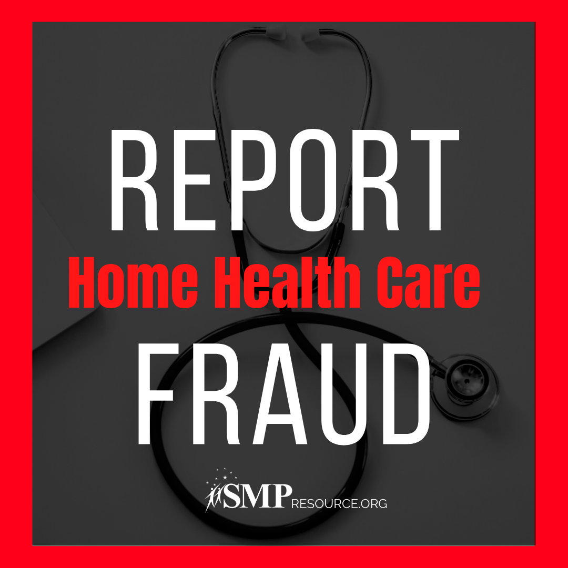
Twitter Post: Today is National #ReportHomeHealthCareFraudDay.
Be cautious when you are offered money or "free" services in exchange for your Medicare card number. To report home health care fraud, contact your local #SeniorMedicarePatrol at 877.808.2468.
Note: Space was provided along the bottom left or right for your state logo and contact information. Do not remove the national logo, citations, or grant statement.
