SMP Scam Watch Cardiovascular Genetic Testing Fraud
7.22.21
Facebook Post: Cardiovascular genetic testing fraud occurs when Medicare is billed for a cardio type of test or screening that was not medically necessary and/or was not ordered by a beneficiary’s treating physician.
If Medicare denies the cardiovascular genetic test claim, you could be responsible for the entire cost of the test averaging $9,000 to $11,000.
Be on the lookout for:
- Calls stating your cardiologist requested this test
- Offers of "free" or "no cost to you"
- Test kits that show up in the mail
Contact the #SeniorMedicarePatrol to report cardiovascular genetic testing scams at 877-808-2468.
Note: Space was provided in the lower portion for your state logo and contact information. Do not remove the national logo, citations, or grant statement.
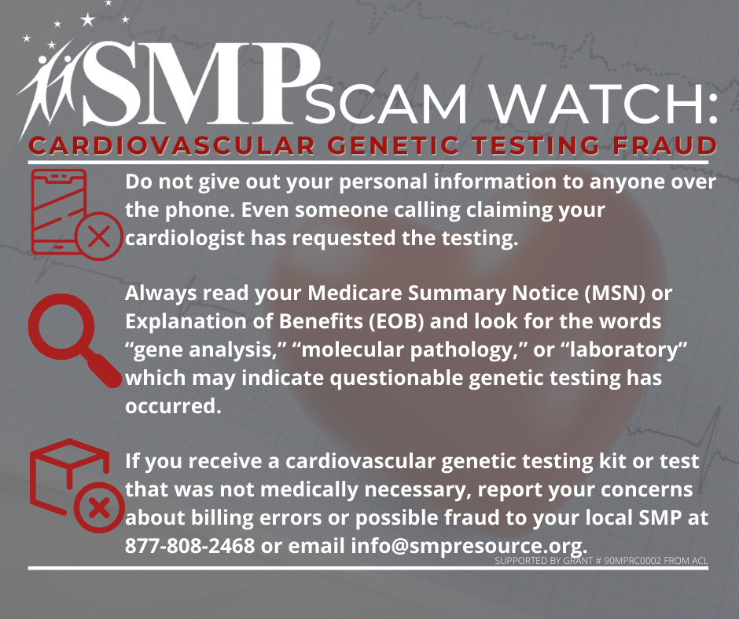

Twitter Post: Here are 4 tips to help prevent #Medicare fraud. Even if the caller has your name, address, birthday, or any other personal information, hang up. You can call your doctor or Medicare yourself to verify the call. Contact the #SeniorMedicarePatrol for more information.
Note: Space was provided in the lower portion for your state logo and contact information. Do not remove the national logo, citations, or grant statement.

