SMP Warning: Genetic Testing Scam
6.28.21
Facebook Post:
Be aware of genetic testing scams. If someone calls you about a genetic testing kit, or mails you one, deny it. If you are approached by someone out in the public to swab your cheek for genetic/DNA/cancer testing, deny it. Medicare only covers this type of testing in rare, medically necessary cases.
If you have been sent a kit or approached about genetic testing, contact your local #SeniorMedicarePatrol and report it! Call 1-877-808-2468 or use the state locator at www.smpresource.org.
Note: Space was provided in the bottom of the white box for your state logo and contact information. Do not remove the national logo, citations, or grant statement.

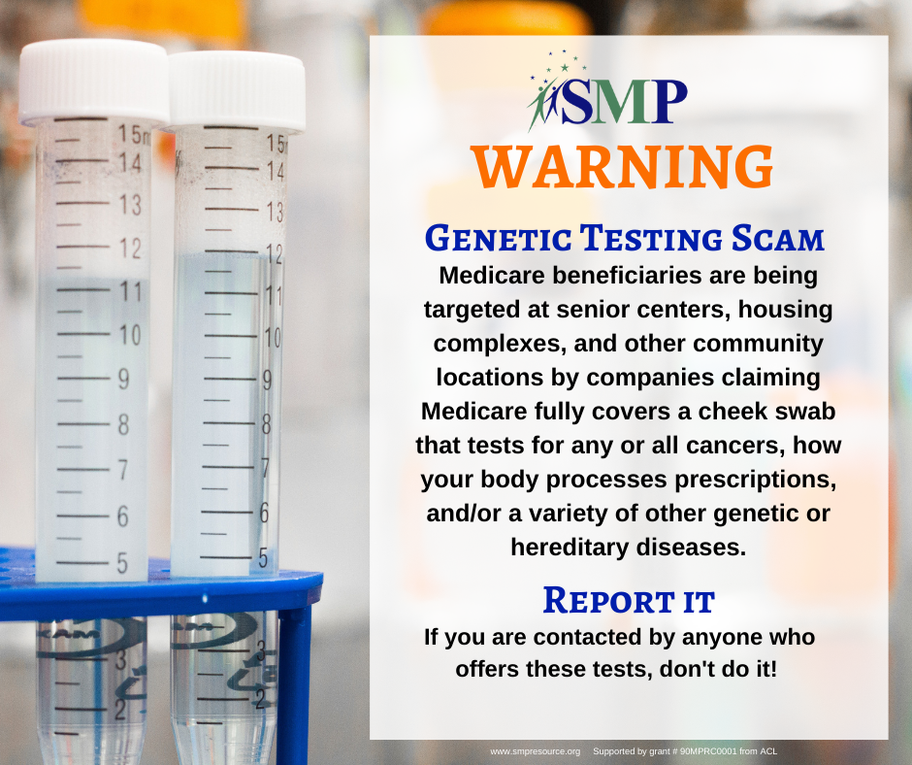

Twitter Post: If you have been sent a kit or approached about genetic testing, contact your local #SeniorMedicarePatrol and report it! Call 1-877-808-2468 or use the state locator at www.smpresource.org.
Note: Space was provided in the bottom of the white box for your state logo and contact information. Do not remove the national logo, citations, or grant statement.
