SMP Scam Watch: Telehealth
1.12.22
Facebook Post: Telehealth services are a benefit for many people who are unable to physically go to a doctor's office. Scammers realize this and are using it to their advantage. Be sure to review your Medicare statements and see if you have been charged for any telehealth service you did not receive or did not schedule. If you need assistance in doing this, contact your local SMP to help. The #SeniorMedicarePatrol can be found by using the state locator at www.smpresource.org.
Instagram Post: #Telehealth services are a benefit for many people who are unable to physically go to a doctor's office. #Scammers realize this and are using it to their advantage. Be sure to review your #Medicare statements and see if you have been charged for any telehealth service you did not receive or did not schedule. If you need assistance in doing this, contact your local SMP to help.
The #SeniorMedicarePatrol can be found by using the state locator at www.smpresource.org.
Note: Space was provided in the bottom right corner for your state logo and contact information. Do not remove the national logo, citations, or grant statement.
The below image is used for both Facebook and Instagram and can be scheduled to Instagram directly from Facebook Business Suite, if you would like.
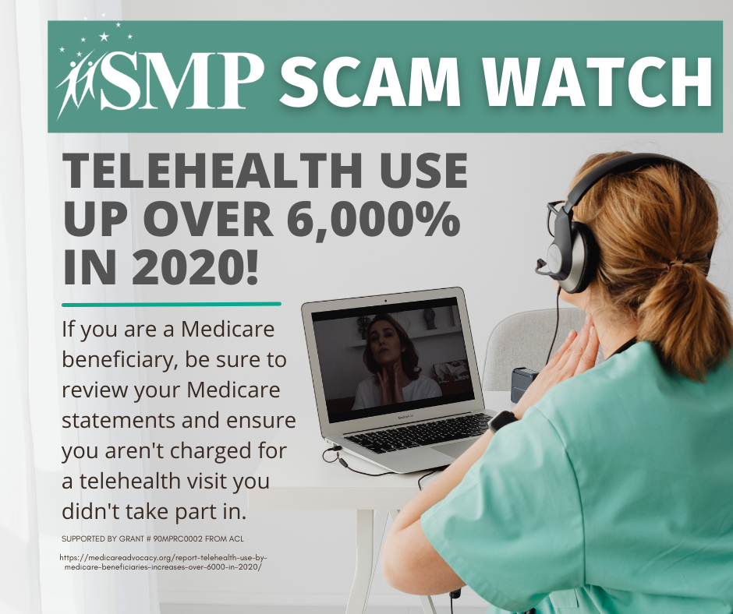
Twitter Post: #Telehealth services are a benefit for many people who are unable to physically go to a doctor's office. #Scammers realize this and are using it to their advantage. Contact the #SeniorMedicarePatrol to report #MedicareFraud. www.smpresource.org
Note: Space was provided in the bottom left corner for your state logo and contact information. Do not remove the national logo, citations, or grant statement.
