Unwanted braces or test kits
6.16.21
Facebook Post: Back brace and genetic testing scams continue to be common complaints when it comes to Medicare scams. Here is what to do if you receive unwanted braces or kits. Contact the #SeniorMedicarePatrol at 877-808-2468 or email info@smpresource.org to be connected to your state SMP.
Note: Space was provided in the bottom right corner for your state logo and contact information. Do not remove the national logo, citations, or grant statement.
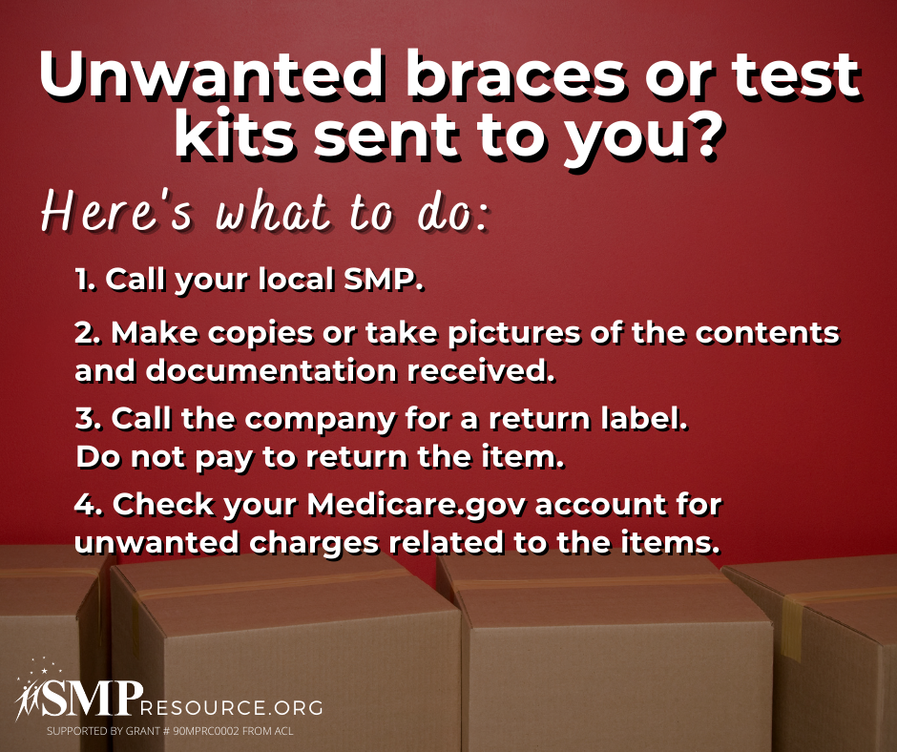

Twitter Post: Back brace and genetic testing scams continue to be common complaints when it comes to Medicare scams. Here is what to do if you receive unwanted braces or kits. Contact the #SeniorMedicarePatrol at 877-808-2468 or email info@smpresource.org to be connected to your state SMP.
Note: Space was provided in the bottom right corner for your state logo and contact information. Do not remove the national logo, citations, or grant statement.
