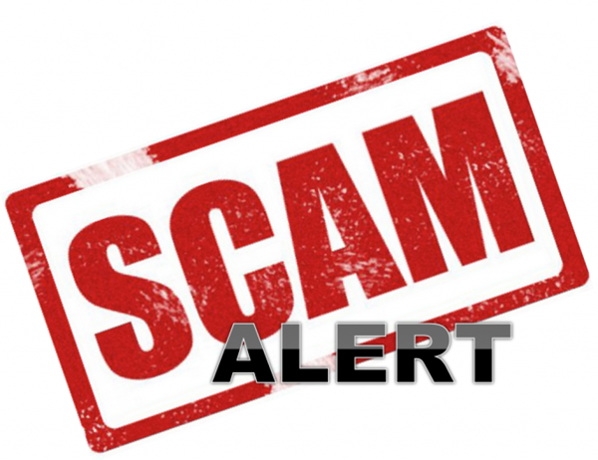
COVID-19 Vaccine Fraud
The good news- Senior Medicare Patrol (SMP) hasn’t yet seen extensive COVID-19 vaccine fraud nationally.

The bad news- This type of fraud will move very quickly, very soon, and will take many forms. What you need to know:
- You likely will not need to pay anything out of pocket to get the vaccine during this public health emergency.
- You cannot pay to put your name on a list to get the vaccine.
- You cannot pay to get early access to the vaccine.
- No one from Medicare or the Health Department will contact you.
- No one from a vaccine distribution site or health care payer, like a private insurance company, will call you asking for your Social Security number or your credit card or bank account information to sign you up to get the vaccine.
- Beware of providers offering other products, treatments, or medicines to prevent the virus. Check with your health care provider before paying for or receiving any COVID-19-related treatment.
- If you get a call, text, email — or even someone knocking on your door claiming they can get you early access to the vaccine, STOP! It’s a scam!
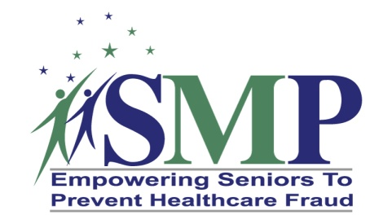
Please report any suspicious contacts to the Wyoming Senior Medicare Patrol
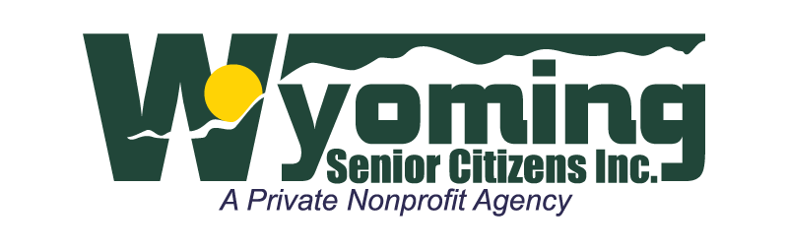
Riverton 1 800 856-4398
Casper 1 877 634-1006
Cheyenne 1 877 634-1005

This project was supported in part by grant number 90MPPG0014 from the U.S. Administration for Community Living, Department of Health and Human Services, Washington, D.C. 20201.

