What Can You do to Stop DME Fraud?
Posted 5.12.21
Facebook Post: Are you getting calls about "free" braces? Here are a few tips to stop durable medical equipment (DME) fraud. Contact your local #SeniorMedicarePatrol for more information or to report fraud at 1-877-808-2468.
Note: Space was provided in the bottom right corner for your state logo and contact information. Do not remove the national logo, citations, or grant statement.

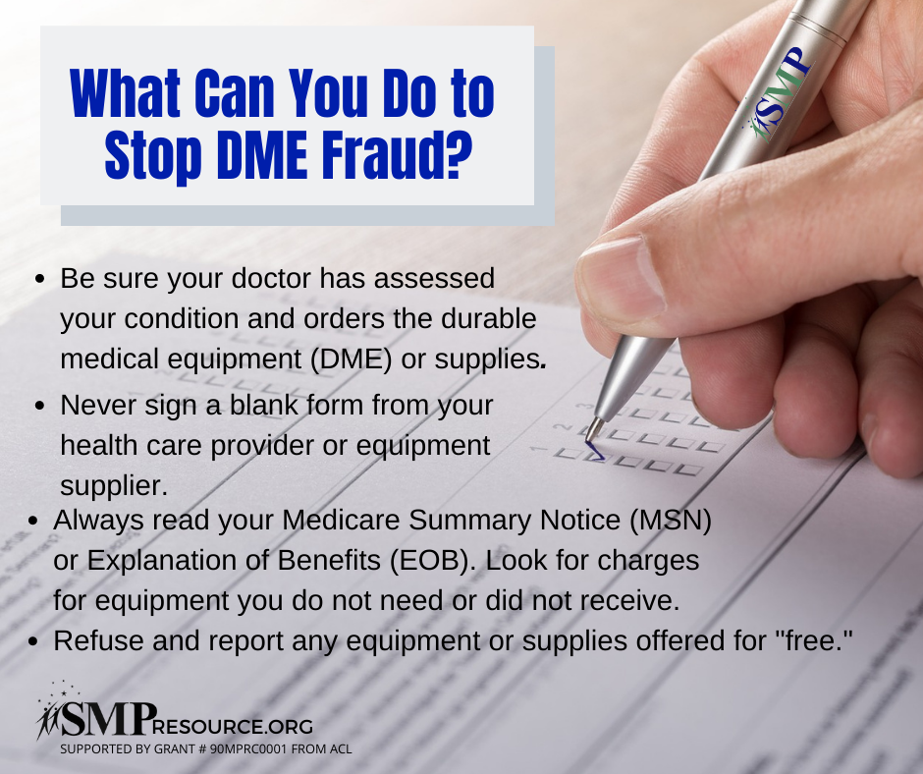

Twitter Post: Are you getting calls about "free" braces? Here are a few tips to stop durable medical equipment (DME) fraud. Contact your local #SeniorMedicarePatrol for more information or to report fraud at 1-877-808-2468. #DME #DMEFraud #Medicarefraud
Note: Space was provided in the bottom right corner for your state logo and contact information. Do not remove the national logo, citations, or grant statement.
